Communications Baseband
Project 05500

Critical Design Report
May 13, 2005

Sponsor: RIT EE Dept.
Advisors: Dr. Joe DeLorenzo,
Dr. Sohail Dianat, Dr. Eli Saber

Team Leader: Leland Smith (EE)
Chief Engineer: Jason Riesbeck (EE)
Electrical Engineer: Jonathan Hutton

This page intentionally left blank.

Executive Summary

This document provides full detail of the planning and design of the project Communications Baseband. The name Communications Baseband is actually a misnomer that originated before the project was redefined by the project leader and advisor Dr. Joe Delorenzo. Initially this project was to be a base-band signal processing project that would perform digital signal processing and coding which would then be modulated and encoded by a Forward Error Correcting project from last year.
This critical design report (CDR) is broken down to a system level. Because this project is three distinct systems that achieve the same goal, this CDR separates each system as a unique project. Typical design reports break the project down into facets of the design process from proposal to refinement. However, this project consists of multiple, unique systems; thus, this CDR is divided by ‘subassembly.’ Each subassembly refers to an individual, independent, fully functional system. Under each of these subassemblies, the important design facets are addressed.
First, the background and purpose of the project are discussed. The system definition and development are then discussed. Subsequently, each subsystem is discussed down to a component level with the design process being clearly outlined. After the design outline, a detail of the problems encountered in design are discussed. The final product is then presented.
Finally, the possible future improvements and upgrades of the project are discussed and how this project can be used as a lab is mentioned.

This page intentionally left blank.
Table of Contents

Executive Summary 3
1 Project Purpose and Introduction 9
1.1 Project Mission Statement 9
1.2 Background 9
1.3 Customers 10
1.4 System Overview 10
1.5 Customer Specifications 12
1.6 Project Feasibility 14
1.7 Deliverables 14
2 System Concept Development 16
2.1 Initial System Proposals 16
2.2 Analysis of Design Proposals 20
2.3 Design Refinement 21
2.4 System Feasibility 28
2.5 Deign Criteria 28
3 Audio Subassembly 30
3.1 Subsystem Introduction 30
3.2 Concept Development 31
3.3 Feasibility Assessment 32
3.4 Design Objectives 32
3.5 Design Synthesis 34
3.6 Results 39
3.7 System Definition 40
3.8 Future Improvements 42
4 AM Subassembly 43
4.1 Subsystem Introduction 43
4.2 Concept Development 44
4.3 Feasibility Assessment 47
4.4 Design Objectives 48
4.5 Design Synthesis 50
4.6 Results 54
4.7 System Definitions 56
4.8 Future Improvements 59
5 FM Subassemblies 59
5.1 Conceptual Design 59
5.2 Preliminary Feasibility Assessment 61
5.3 Concept Development 61
5.4 Feasibility Assessment 62
5.5 Target Specifications 63
5.6 Design Documents 63
5.7 Design Synthesis 64
6 FSK Subassembly 70
6.1 Preliminary Feasibility Assessment 70
6.2 Concept Development 70
6.3 Feasibility Assessment 72
6.4 Target Specifications 72
6.5 Design Documents 73
6.6 Design Synthesis 73
7 Digital Processing and Control Subsystem 75
7.1 Subsystem Introduction 75
7.2 Concept Development 76
7.3 Feasibility Assessment 85
7.4 Design Objectives 86
7.5 Design Synthesis 90
7.6 System Definition 98
7.7 Final Design 99
7.8 Future Improvements 101
8 Project Results and Improvements 101
8.1 Senior Design II Time Line 101
8.2 System Functionality 101
8.3 Budget 102
8.4 Future Improvements 103
Appendix A – References 105
Appendix B – Design Documents 106
FM Transmitter Schematic 107
Parts List – FM Transmitter 108
Interconnection Control Document - FM Transmitter Board 109
Test Procedure – FM Transmitter 110
FM Receiver Schematic 111
Parts List – FM Receiver 112
Interconnection Control Document - FM Receiver Board 113
Test Procedure – FM Receiver 114
FSK Transceiver Schematic 115
Interconnection Control Document - GFSK Board 117
Test Procedure – GFSK Transceiver 118
GFSK Board Protocol Guidelines 119
GFSK Control Word 122
Further Look into ISM Band Regulations 123
Choosing Capacitors 124
PIC Microchip TX Side – With Synchronization Word 127
PIC18F2525 RX Side – With Synch Word Reception 137
PIC18F2525 Code RX Side – No Synch Word 146
Simulation Code for Quantization 155
PCM Simulation 156
DSB Simulation Code 157
Simulation AM 158
Choosing a DAC 159
Logarithmic Amplifier 161
A/D Conversion and the PICmicro Crystal Oscillator 162

List of Figures
Figure 1 - Organizational Work Chart 12
Figure 2 – Concept #1 Universal AM/FM/ASK/FSK System 16
Figure 3 – Concept #2 Analog Voice and Wireless RS232 18
Figure 4 – Concept #3 Wireless USB 18
Figure 5 – Concept #4 Analog Voice and Streaming Audio 19
Figure 6 – Subsystems Block Diagram 22
Figure 7 Basic Block Diagram of Transmitter Side Audio Subsystem 30
Figure 8: Basic Block Diagram of Receiver Side Audio Subsystem 31
Figure 9: Filter Representation 32
Figure 10: Example Op-Amp in Gain Formation 35
Figure 11: 1st Iteration LPF Schematic 37
Figure 12: 1st Iteration LPF Frequency Response 37
Figure 13: 2nd Iteration LPF Schematic 38
Figure 14: 2nd Iteration LPF Frequency Response 38
Figure 15: Anti-Aliasing Filter Layout 39
Figure 16: Anti-Aliasing Filter Results 40
Figure 17: Audio Subsystem Circuit Diagram - Input 41
Figure 18: Audio Subsystem Circuit Diagram – Output 41
Figure 19: Basic Block Diagram of AM Transmit Subsystem 44
Figure 20: Basic Block Diagram of AM Receive Subsystem 44
Figure 21: Envelope Detector 47
Figure 22: Clock Oscillator and RLC Filter 51
Figure 23: RLC Filter 55
Figure 24: Audio Input Buffer 55
Figure 25: Clock Oscillator and Buffer Amplifier 56
Figure 26: Audio Input Buffer 57
Figure 27: Mixer, RF Amplifier, and Antenna 57
Figure 28: Antenna and AM Receiver 58
Figure 29 – Frequency Modulation of a Carrier 60
Figure 30 – Basic FM Transmitter 60
Figure 31 – Basic Superheterodyne FM Receiver 61
Figure 32 – FM Receiver Board 65
Figure 33 – FM Transmitter Board 65
Figure 34 – Board Layout for FM Transmitter, FM Receiver, and FSK Transceiver 66
Figure 35 – Short Removed from Board 67
Figure 36 – Input Audio with Distortion Problem 68
Figure 37 – Input Audio after Resolution of Distortion Problem 68
Figure 38 – Added Inductance to Back of FM Transmitter 69
Figure 39 – FSK Transceiver Board 74
Figure 40 – Capture of Transmitted and Received Data 75
Figure 41 – Digital Processing and Control Subsystem Block Diagram 76
Figure 42 - Spectrum of original signal 79
Figure 43 - Frequency Spectrum of Sampled Signal 79
Figure 44 - Quantization of an analog signal into L levels 80
Figure 45 - PIC Transmit Side Program Flow Chart 88
Figure 46 - Receive side PIC program flow chart 89
Figure 47 - Timing Diagram for FSK Chip in Shockburst Mode 92
Figure 48 - Asynchronous Data Transmission – 2 Samples 93
Figure 49 - Asynchronous Data Transmission - 1 Sample 94
Figure 50 - Final Transmission Protocol - Synchronous Mode 95
Figure 51 - TX Data and RX Data Received Wirelessly 96
Figure 52 - Receiver Out of Synch 97
Figure 53 - Transmit Side Pin to Pin PIC-FSK Connections 98
Figure 54 - Receiver Side Pin to Pin FSK -PIC-DAC Connections 99
Figure 55 - TX Side PIC Hardware 100
Figure 56 - RX Side PIC 100

Project Purpose and Introduction
This section will introduce the project goals, purpose, and history. The customers will be acknowledged and their specifications delineated. A system overview and diagrams will be given. Finally the project timeline and deliverables will be proposed.

Project Mission Statement
The goal is to have a communications system consisting of a modulator and demodulator such that three methods of modulation are employed on an analog signal (namely AM, FM, and PCM). To be sure the project is completed by Senior Design II, only analog input signals (e.g. music or voice) will be considered for the system.
The system will wirelessly transmit the modulated signal a classrooms length to a demodulator. The demodulator will perform the reverse process and output the analog voice signal to a speaker. The system will allow for a spectrum analyzer and other lab equipment to easily connect to it for viewing the spectrum of the modulated signal.

Background
This project was initiated in a cumulative effort of professors in the RIT electrical engineering department to provide interactive laboratory equipment that would demonstrate the application of communications theory. The implementation of several modulation techniques will support a corresponding class in communications theory. The desire was to have a system such that different methods of modulation are employed on an input signal. This will be used to show students useful information such as the frequency spectrum of each modulated signal.

Customers
The customers for this project are Dr. Joe Delorenzo, Dr. Eli Saber, and Dr. Sohail Dianat. They are all professors at Rochester Institute of Technology and teach the communications courses for undergraduate and graduate level. Ultimately, the RIT electrical engineering department is the end customer since this project will be used for the undergraduate communications class. The RIT EE department is the sponsor for the cost of materials.

System Overview
This system will implement three types of modulation on an analog input. The project can be broken into major functions that must be performed. Each of these functions is found in the systems as defined in Chapter 2 and described in detail in the rest of the document. These main system functions are outlined as follows:
- Analog Input (Source)
- Analog Processing
- Amplitude Modulation/Demodulation
- Frequency Modulation/Demodulation
- Analog to Digital Conversion (PCM)
- Frequency Shift Keying (FSK modulation/demodulation)
- Digital to Analog Conversion
- Analog Output (Sink)
The analog input in our project will be a standard vocal microphone. Also line level audio may be plugged in from any audio source (e.g. compact disk player, MP3 player, etc.). Analog processing will modify the analog signal so that it is suitable for digital conversion and modulation. The signal will be amplified and then passed through a low pass filter to attenuate any unwanted frequencies. This will be necessary to prevent aliasing when the analog signal is sampled. These things are all part of the audio subassembly and are subsequently discussed in Chapter 3.
Amplitude modulation and demodulation will be performed on the analog signal as a separate system. This is discussed in detail in Chapter 4. Frequency modulation is also its own system that modulates the analog audio as discussed in Chapter 5.
Analog to digital conversion will be used to implement base-band pulse code modulation. This is part of the digital processing and control subsystem discussed in Chapter 7.
Frequency Shift Keying is the method of modulation used to wirelessly transmit the binary PCM signal stream.
Digital to analog conversion is part of the audio processing discussed in Chapter 7.
Finally the received analog signal must be conveyed to show that successful demodulation has occurred. In this project, only audio signals are used therefore the output will be a speaker for human hearing of the transmitted signal.

Project Organizational Chart
The following chart in Figure 1 shows the organizational chart of the project.
Figure 1 - Organizational Work Chart

Customer Specifications
The advisors did not require very detailed specification. Rather it was more of an open ended project with the main specification being a functional system that modulates and demodulates in AM, FM and PCM. The most important specifications were that it be completed by May and be suitable for using in the classroom as a demonstration tool. Any additional time we may have may be used to add additional functionality to the project.
The minimum specifications for the project were defined by the advisors and are delineated here.
- The input signal should be from a microphone or some other analog device.
- The bandwidth or range of the input analog signals should be at least voice quality audio.
- The modulation methods employed should be AM (amplitude modulation), FM (frequency modulation), and PCM (pulse code modulation) version of the input.
- There should be some means of viewing the spectrum of the modulated signal on a spectrum analyzer.
- The project should be wireless with a minimal range of a room size.
- A suitable receiver should demodulate the signal and send it to an appropriate sink (e.g. a speaker or computer for digital) so there is some way of knowing the signal was successfully received.
- The project should consist of two self-contained modules that provide modulation of the analog signal and demodulation of the transmitted signal.
- All circuitry and components necessary to complete these two operations should be contained in some solid container allowing visibility of the components and portability of the unit.
- An external microphone should be provided and the necessary input jacks mounted to the transmit module.
- The receive module should have a mounted speaker and any necessary output ports to access the demodulated signal.
- Antennas should be mounted to the module.
- Each module should have appropriate labeling of all peripherals.
- Each module should have control switches to select which modulation scheme is to be used.
The fundamental design objectives were weighted to show which design parameters are most important. Table 1 - Fundamental Design Objective Weight Chart shows these weights and their corresponding design parameter.
Fundamental Design Objectives | Weight
Completed by May | 10
Cummunicates using: AM, FM, and PCM | 10
Has range of a classroom length | 9
Suitable for Evaluation in a Laboratory | 7
Affordable for Customer | 6
Easy to Use | 5
Minimal Amount of External Equipment | 4
Table 1 - Fundamental Design Objective Weight Chart

Project Feasibility
The project specifications listed above were the minimum specification based on what the team and advisors thought could be accomplished in the given two quarter period. The team members were at liberty to decide which components of the project could feasibly be designed and hand built and which ones should purchased.
Because this project is a broken into individual systems a full system feasibility analysis is not appropriate. It is at the subassembly level that the decision of which off the shelf components were reasonable to use and which components were feasible to design. Thus the feasibility is discussed for each subassembly.

Deliverables
The Communications Baseband team shall provide the following to our customers and RIT EE department at the end of the two quarter series of Senior Design I and II, May 2005:
- 1 Transmit module capable of modulating an analog input using AM, FM and PCM.
- 1 Receiver module capable of demodulating the transmitted signal in either AM, FM, or PCM.
- Operator Manual with complete I/O specifications for each board and each module, operation instructions, conditions of operation, and any other appropriate information regarding the use of the system.
- Critical Design Report: A final report that contains detailed documentation of the design process of the system, final diagrams detailing the module and subsystem signal flow, calculations and mathematical derivations, variations in operation from specifications (if any), implementation caveats, simulation results and source codes, summary of test results, known issues or problems, and final conclusions.

System Concept Development
This section develops the project at a system level. A design process is used to narrow in on a final design after brain storming. Then the selected system is broken into subsystems, and specific task are designated for each.

Initial System Proposals
The team proposed a variety of system architectures. In this section the pilot systems will be introduced. Each idea will be discussed and analyzed. Ultimately, impracticable designs will be dismissed for reasons of unfeasibility or unmet design objectives and a final system design will be reached.

Concept #1 Universal AM/FM/ASK/FSK
The first idea was to create a universal transmitter/receiver that could transmit analog AM, analog FM, ASK, and FSK. The AM and FM modulators would be of typical architecture and would provide enough bandwidth for digital transmission. To transmit analog an audio signal would be placed on the modulator. To transmit digital a digital wave form would be provided. Concept #2 can be found in Figure 1.

Figure 2 – Concept #1 Universal AM/FM/ASK/FSK System

Advantages
- Versatility - It could be used to show students a variety of modulation schemes.

Disadvantages
- Digital Data Rate – In order to the finish the project in the allotted 6-months, off-the-shelf modulators would have to be used. These modulators typically only have a bandwidth in the audio range (5 to 20kHz). This means the data rate would be on the order of 40kbps
- Usefulness – The question is still asked “what will the digital portion be used for?” The operator would have to provide a digital signal for demonstration. The point of the digital portion seems moot without some sort of device to facilitate the transmission of useful digital data.

Concept #2 Analog Voice and Wireless RS232
This concept is similar to the first scheme, however, ASK has been abandoned to simplify the AM portion. Also, the FM portion has been interfaced with the personal computer. This could be used to link 2 PCs or link a PC to a RS232 device.
Figure 3 – Concept #2 Analog Voice and Wireless RS232

Advantages
- Reasonable Bandwidth – Data rates for RS232 are low (20kbps (1b)) making it suitable for an analog channel.

Disadvantages
- Requires Two Way Communication – This will complicate the design slightly.
- Not Particularly a PCM Solution – This solution is still only an audio channel that is to be used to transmit digital data. It may be more useful and educational to have a dedicated digital transmitter.
- Requires Extra Lab Equipment – This setup requires the availability of at least one computer which conflicts with the design objectives.

Concept #3 Analog Voice and Wireless USB
This concept is similar to concept number 2, however, it implements a separate module for PCM transmission and supports wireless USB. Analog AM and FM are also implemented (though not shown in Figure 4).
Figure 4 – Concept #3 Wireless USB

Advantages
- Impressive Bandwidth – USB operates at 1.5 to 480Mbps. Sending data at this speed would be a great achievement.

Disadvantages
- Difficult to Implement – Bit rates of over 1Mbps require high carrier frequencies often in the Ghz range. Extra care is necessary when building a system for Ghz operation. High band width systems also have more noise problems because noise power is passed through the wide front end filter.
- Requires Two Way Communication – This will complicate the design slightly.
- Requires Extra Lab Equipment – This setup requires the availability of at least one computer which conflicts with the design objectives.

Concept #4 Analog Voice and Streaming Audio
In this design, all three modulation schemes have a common audio input. The analog signal is sampled and converted into a digital bit stream. That signal is then transmitted digitally using FSK. On the receive side, the signal is converted back to analog.

Figure 5 – Concept #4 Analog Voice and Streaming Audio

Advantages
- Comparison of modulation schemes – All three modulation schemes can be compared directly because this architecture uses a single audio source. This setup is ideal for demonstrating the tradeoffs of all three sections.
- No external equipment – A demonstration can be performed without an external signal source.
- One Way Communication – This simplifies the design. The setup can easily be converted to dual directional if an extra set of modulators and demodulators are produced.

Disadvantages
There are no obvious disadvantages at this time. One concern is the bandwidth required for uncompressed streaming audio. This figure will be a product of the sample size and the sampling frequency chosen. Thus allowing a few degrees of freedom. Once an analysis of the system is performed, a sample size and rate can be chosen based on the hardware limitations.

Analysis of Design Proposals
The design proposals above were rated based on their conformance with the design objectives. Those values were then be multiplied by the weight of each objective and totaled. Table 2 shows this analysis.
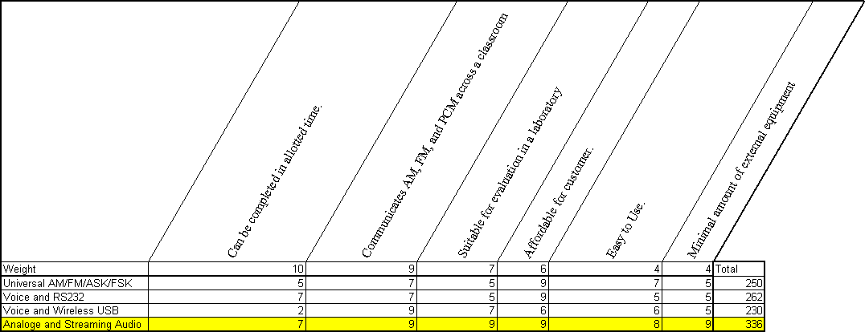
Table 2 – Preliminary System Concept Analysis
Concept number 4 was chosen as the most logical project directive. It accomplishes all project goals and the likelihood of completion by May of 2005 is high.

Design Refinement
It is now necessary to define the system in more resolution. To aid in the development process, the project will be broken up into subassemblies. This way, the workload can be divided amongst the team members and each subsystem can be developed independently. Performance and interconnection specifications will be developed for each.

Definition of Subsystems
The design was split into subsystems based on independent functionality. Figure 6 shows the systems and their interconnection.
Figure 6 – Subsystems Block Diagram

Audio Processing (Transmitter Side)
This system (number 1 in Figure 6) must receive an audio signal from an outside source and distributed it to three adjacent subsystems (AM, FM and Digital).
Input – Input must be in the form of radiated vocals from a human speaking at a nominal volume. Unit must have adjustable gain to facilitate a human speaking at a range of volume levels. These specific levels must be characterized by the designer of the subsystem.
Additional inputs can be added such as a line level RCA input from a stereo or walkman. These addition inputs should only be pursued after the primary input (above) has been satisfied.
Output – Three line level audio outputs must be supplied to adjacent subsystems. These outputs must be adjustable or easily adaptable for connection to a range of subsystems.
Power Consumption and Supply Voltage – This system must operate from a signal supply voltage of 9V DC.

Audio Processing (Receiver Side)
This system (number 2 in Figure 6) must receive an audio signal from the three adjacent subsystems (AM, FM and Digital) and broadcast it from a speaker.
Input – Three line level audio inputs will be supplied from adjacent subsystems. These inputs must be adjustable or easily adaptable for connection to a range of subsystems.
Output – Input must be in the form of radiated audio. This sound must be audible by a typical human in a typical classroom with a typical amount of ambient noise. These specific audio levels must be characterized by the designer of the subsystem.
Additional outputs can be added such as a line level RCA output for a stereo or recording device. These addition inputs should only be pursued after the primary output (above) has been satisfied.
Power Consumption and Supply Voltage – This system must operate from a signal supply voltage of 9V DC.

AM Transmitter
This system (number 3 in Figure 6) must receive an audio signal from the audio board and electromagnetically broadcast it using AM.
Input – The system must be capable of receiving a signal level audio signal
Output – Output must be an AM signal. This system should be designed in conjunction with the AM receiver. It is the responsibility of the designer to characterize the AM signal and determine the signal strength necessary to maintain a wireless link over a distance equal to the length of a classroom.
Power Consumption and Supply Voltage – This system must operate from a signal supply voltage of 9V DC.

AM Receiver
This system (number 4 in Figure 6) must receive an electromagnetically radiated AM and supply a demodulated audio signal to the audio board.
Input – Input must be an AM modulated signal. This system should be designed in conjunction with the AM Transmitter. It is the responsibility of the designer to characterize the AM signal and determine the receiver sensitivity necessary to maintain a wireless link over a distance equal to the length of a classroom.
Output – The system must be capable of delivering a signal level audio signal
Power Consumption and Supply Voltage – This system must operate from a signal supply voltage of 9V DC.

FM Transmitter
This system (number 5 in Figure 6) must receive an audio signal from the audio board and electromagnetically broadcast it using FM.
Input –The system must be capable of receiving a signal level audio signal.
Output – Output must be an FM signal. This system should be designed in conjunction with the FM receiver. It is the responsibility of the designer to characterize the FM signal and determine the signal strength necessary to maintain a wireless link over a distance equal to the length of a classroom.
Power Consumption and Supply Voltage – This system must operate from a signal supply voltage of 9V DC while consuming no more than 100mA of current.

FM Receiver
This system (number 6 in Figure 6) must receive an electromagnetically radiated FM signal and supply a demodulated audio signal to the audio board.
Input – Input must be an FM modulated signal. This system should be designed in conjunction with the FM Transmitter. It is the responsibility of the designer to characterize the FM signal and determine the receiver sensitivity necessary to maintain a wireless link over a distance equal to the length of a classroom.
Output – The system must deliver a line level audio signal.
Power Consumption and Supply Voltage – This system must operate from a signal supply voltage of 9V DC.

FSK Transmitter
This system (number 7 in Figure 6) must receive a digital bit stream from the digital board and transmit it using FSK.
Bit Rate – Bit rate should be high enough to facilitate uncompressed streaming audio. It is the responsibility of the system designer to provide the highest bit rate possible in a design that can be completed in the allotted time.
Digital I/O – Control and data transfer to the FSK board should be conducted through no more than 10 digital control lines. During development, a high level of communication should be maintained between the developers of the FSK and digital control systems. This is recommended to elevate any problems with compatibility.
Output – Output must be an FSK signal. This system should be designed in conjunction with the FSK receiver. The system designer should perform all necessary calculations to be sure that the transmitter and receiver are compatible. Also, signal strength should be strong enough to maintain a wireless link over a distance equal to the length of a classroom.
Power Consumption and Supply Voltage – This system must operate from a signal supply voltage of 9V DC.

FSK Receiver
This system (number 8 in Figure 6) must receive an electromagnetically radiated FSK signal and deliver it to the digital board.
Requirements for digital I/O and bit rate are the same as described in Section (2.3.1.7.) The main requirement is that the receiver be compatible with the transmitter.

Digital Control and PCM Encoding (Transmitter Side)
This system (number 9 in Figure 6) should supply the FSK board with a digital representation of the supplied audio signal. The Digital board will also supply the FSK board with any control that is required.
Input – The system must be capable of receiving a line level audio signal.
Digital I/O – The digital board must supply the FSK board with a digital representation of the analog input. Proper formatting must be done to facilitate transmission via a wireless link. The digital portion must also provide the FSK board with the proper control information. The designer must work with the designer of the FSK portion to make sure all requirements are met.
Power Consumption and Supply Voltage – This system must operate from a signal supply voltage of 9V DC while consuming no more than 100mA of current.

Digital Control and PCM Encoding (Receiver Side)
This system (number 10 in Figure 6) should retrieve data from the FSK receiver and transform it back into an audio signal. The Digital board will also supply the FSK board with any control that is required.
Output - The system must supply the audio board with a line level audio signal.
Digital I/O –The digital portion must provide the FSK board with the proper control information. Also, the designer must work with the designer of the FSK portion to make sure that the two boards can communicate with each other.
Power Consumption and Supply Voltage – This system must operate from a signal supply voltage of 9V DC.

Power Supplies
These systems (numbers 11 and 12 in Figure 6) will provide power to all of the subsystems. To avoid cross contamination of power supply noise between systems, both supplies on the receiving and transmitting side will provide a single voltage of 9VDC. Each subsystem will be responsible for regulating the voltage down to the necessary levels. Each of these regulators will provide isolation from the 9V supply and thus will prevent noise contamination. Another reason to have one regulator per subsystem is to prevent noise from the wring harness. Noise picked up in the wiring harness will be filtered out by the regulators.
The power supply unit should be comprised of off-the-shelf batteries or a 120VAC to 9DC power supply(s).

System Feasibility
The development of this system has revolved around the idea that feasibility should be assessed at a subsystem level. If the design responsibilities and criteria are met, system integration should be straight forward. The engineers of each subsystem have the ability to tailor system architecture and minor performance specifications in the name of product achievability. Therefore, a system level feasibility assessment is not necessary. If it is found that one of the subsystems is not feasible, this estimation can be revisited.

Deign Criteria
Most of the system level design specifications have been defined in the above sections. The fundamental standard is that individual designs adhere to the subsystem definitions above.

Interconnections
Additionally, to maintain connectivity and modularity between subsystems a standard is set for subsystem connectors. Once the subsystems are defined, they can be interfaced with a wiring harness using the connectors defined herein.

Connector Use | Connector Type
Power Supply | Male, Single Row, 0.1" on center headers
Audio Signals | Male, Single Row, 0.1" on center headers
Digital Control Lines | Male, Double Row, 0.1" on center headers
RF Signals | Female, 50ohm, SMA
Table 3 – Subsystem Connector Types

FCC Considerations
Subsystems which produce RF signals must comply with FCC regulations. Radiating system should operate in an unlicensed band or stay under a power level of 100mW. More power can be used if a frequency is chosen from Table 4.
Country | Frequency | Notes
US | 2.400-2.483.5 GHz | ISM Band (max 1W, 4W EIRP)
 | 902-928 MHz | ISM Band (Used by GSM in most countries)
 | 5.800-5.925 GHz | ISM Band
 | 5.15-5.25 GHz | U-NII (Unlicensed - National Information Infrastructure) max. 200 mw EIRP
 | 5.25-5.35 GHz | U-NII max. 1w EIRP
 | 5.725-5.825 GHz | U-NII max. 4w EIRP
Table 4 – Unlicensed Frequency Bands
For ISM band transmissions, antenna gain can be as much as 6dB. After which, the transmit power must be reduced by 1dB for every 1dB increase in antenna gain. For transmission in the broadcast FM range (88-108MHz) signal must not exceed 250 microvolts/meter at 3 meters from the transmitter (FCC rule 15.239). However, transmissions from an unlicensed source may not, under any circumstances, interfere with a licensed source. Therefore, care must be taken to not transmitter on a frequency which is currently occupied by a licensed station.

Audio Subassembly
This section will introduce the input subsystem through all of its steps of design. The conceptualization, mathematical basis, feasibility, and preliminary design will be given.

Subsystem Introduction
The audio subsystem is a very important system in the Communications Baseband senior project. The message signal is put connected to the Audio subsystem, gain is adjusted, and the signal is cleaned up and put into separate gain block to prepare the signals for the individual transmitters. A basic block diagram is shown in Figure 7. The goal of this subsystem is to take an input signal from a microphone or a line level source and prepare it for modulation and transmission in subsequent subsystems. There will also be a separate audio subsystem on the receiver side of the system. The block diagram for the output is shown in Figure 8.
Figure 7 Basic Block Diagram of Transmitter Side Audio Subsystem
Figure 8: Basic Block Diagram of Receiver Side Audio Subsystem

Concept Development
The input into a system that will be processing audio signals is a reasonably standard concept. Digital Signals Processing (EEEE 677) dealt with the input into a system. The students in this class learned that an input signal needs an anti-aliasing filter before anything else is done to the signal. Without this anti-aliasing filter, the danger of aliasing is greatly increased. The main effect of aliasing is to add high frequency information to the low frequency information, destroying both. There are two problems with this: high frequencies are usually noise and once aliasing takes place, there is no practical or theoretical method to recover the original signal.
Since aliasing is definitely a negative situation, a filter to confirm that aliasing will not occur is a necessity. Figure 9 shows the filter as the square over one sample of the signal. There are many standard cut-off frequencies, but most importantly, the cut-off frequency must be less than half of the sampling frequency. The filter will be included on the receiver side of the system to limit the bandwidth of the input to the speaker amplifier.
Ω
Xs(jΩ)
Ω_{N}
-Ω_{N}
Ω_{s}
2Ω_{s}
3Ω_{s}
-Ω_{s}
-2Ω_{s}
(Ωs-ΩN)
Figure 9: Filter Representation
The Digital Signals Processing class or textbook did not mention everything necessary for a system to work; the class and textbook assumed the input message would be equal to the input specifications every time. Unfortunately, in the physical world, input voltages are changing. To properly deal with this, a gain block needs to be in the system as shown in Figure 7. This gain block will be manually adjustable to accommodate the listening needs of the end user.

Feasibility Assessment
The feasibility of the audio subsystem is not in doubt. There are textbooks to assist in the building of the filters and through experience gain blocks are easy to construct.

Design Objectives
The design objectives are given in this section to assist in the design of each component of the Audio Subsystem.

Microphone
The input device was the first piece of the audio subsystem looked at for the objectives. The main objective here was the cost, power, and utility of the microphone. If the microphone is quite easy to break, it would be a poor choice for a laboratory, since items are accidentally dropped. The cost is the other major factor, since the project is attempting to stay as low cost as possible. The microphone should have output voltages of 0V to 5V, to allow the design of the next stage to continue. The input for the microphone should be ¼ inch, rather than the higher end XLR. This is a standard plug and thus will support other types of analog devices.

Gain Block
The second stage of the Audio subsystem is the gain block. The input device will have fluctuating input voltage amplitude, making the specifications for the next stage harder to set. This block will allow the user to modify the input signal by a certain amount of gain. The range in voltage should be 0V to 5V from the previous stage, but the average speaking level of most people is between 1-3 V. The gain of this block should be ½ up to five times the input level. This should be manually adjustable for the user.

Low Pass Filter
The goal of this input subsystem is to take in voice information from a microphone or to take in line level information from a CD player or other systems of that ilk. Human ears can detect sounds from 30 Hz to 20 kHz, therefore any input frequencies higher than that do not matter. The Human voice is approximately 200 Hz through 3.5 kHz. Since to most basic goal of the project is to use Human voice input through the microphone, a low pass filter with a cut-off of 5 kHz would be sufficient. However, an analog input device like a CD player uses the entire spectrum of Human hearing. To accommodate this, a filter with a cut-off of 20 kHz would be best. The standard sampling rate for a CD is 44.1 kHz; if the same quality of sound from our digital system is desired as from a CD, the maximum sampling frequency is 22.05 kHz. The filter is over designed, using the stop-band as 22 kHz. For the design, the pass-band can have a ripple of up to 0.5 dB. This translates into 94.4%-105.6% of the input signal level. The stop-band was chosen to have 20dB of attenuation. This translates into 10% of the input signal or less.
A low-order filter is desired. If the filter has too many orders (greater than 10) the system is harder to implement using discrete parts. A filter that is only a fourth or fifth order would be optimum for this design. Those two orders are chosen for their ability to filter well, offset by the difficulty to design and implement. An easy method to reduce the order of the filter would be to use active components, but doing so would increase the design time and understanding necessary to successfully achieve the desired results. The design will be limited to Op-Amps and passive components.

High Power Op-Amp
A high-power Op-Amp is needed to drive a speaker, or other parts of the project that require a large amplification of a signal. The minimum requirement is a single channel output, but a double channel output leaves room for expansion in the future. The low-cost alternative is a desired result.

Speaker
The speaker must be able to handle the input conditions from the High-Power Op-Amp. Price and size are also considerations, with price being more heavily weighted.

Design Synthesis
This section describes the design of each component in the Audio subsystem.

Microphone
Three brands of microphones were analyzed for their usefulness for this project: Peavey, Radio Shack and Nady. Radio Shack was chosen for their price and ease of procurement. Their Unidirectional Dynamic Microphone costs $19.99 and there is no shipping charges.

Op-Amp
The design will use TL072 Op-Amps that are capable of receiving a ±18 V signal. The price is $0.64 and there is two Op-Amps per 8 pin DIP. Using a potentiometer and a resistor, the gain will be able to be adjusted from ½ to 5. The potentiometer will be adjustable between 5 kΩ and 50 kΩ while the resistor will be a 10 kΩ resistor. The system will be set-up as shown in Figure 10.
Figure 10: Example Op-Amp in Gain Formation

Low Pass Filter
The textbook referenced in this section is: Design of Analog Filters by Rolf Schaumann and Mac E. Van Valkenburg.

Butterworth Filter
In designing filters, the first step is to try a simple filter. The first filter attempted is the Butterworth Filter. The design equations follow:
$ε^{2}={\text{10}}^{0\text{.}1∗α_{\text{max}}}−1$ Equation 3.5.3-1
$n=\frac{\text{log}\left[\left({\text{10}}^{0\text{.}1∗α_{\text{min}}}−1\right)/\left({\text{10}}^{0\text{.}1∗α_{\text{max}}}−1\right)\right]}{2\text{*log}\left[\frac{ω_{s}}{ω_{p}}\right]}$ Equation 3.5.3-2
Using the design specifications and the design equations 1 and 2, n (the order of the filter) is found to be 36. A 36th order filter does not meet the design specification of being a low-order filter.

Elliptical Filter
The next filter attempted is an Elliptical Filter. The design equations follow:
$ε^{2}={\text{10}}^{0\text{.}1∗α_{\text{max}}}−1$ Equation 3.5.3-3
$\begin{aligned}A_{1}={\text{10}}^{−0\text{.}\text{05}∗α_{\text{max}}} \\ A_{2}={\text{10}}^{−0\text{.}\text{05}∗α_{\text{min}}}\end{aligned}$ Equations 3.5.3-4a and 4b
Using Design Figure 8.16:
n=4
A fourth order filter is within the design specifications for the Low-Pass Filter. Using Design Table 8.5, the transfer function of the filter is:
$T(s)=\frac{0\text{.}\text{1399}\left(s^{2}+1\text{.}\text{2909}\right)\left(s^{2}+4\text{.}\text{3497}\right)}{\left(s^{2}+1\text{.}\text{0274}s+0\text{.}\text{7858}\right)\left(s^{2}+0\text{.}\text{1264}s+1\text{.}\text{0520}\right)}$ Equation 3.5.3-5
The schematic or this original transfer function is shown in Figure 11. The frequency output is shown in Figure 12.
Figure 11: 1st Iteration LPF Schematic
Figure 12: 1st Iteration LPF Frequency Response
The second iteration of the design process used new, realistic values for the resistors and capacitors, attempting to get a real working filter. The resistor values were tweaked, rounded, and re-simulated to find working values. The output schematic is shown in Figure 13. The frequency response is shown in Figure 14. From the values on the screen, the attenuation at 22.05 kHz is equal to .
Figure 13: 2nd Iteration LPF Schematic
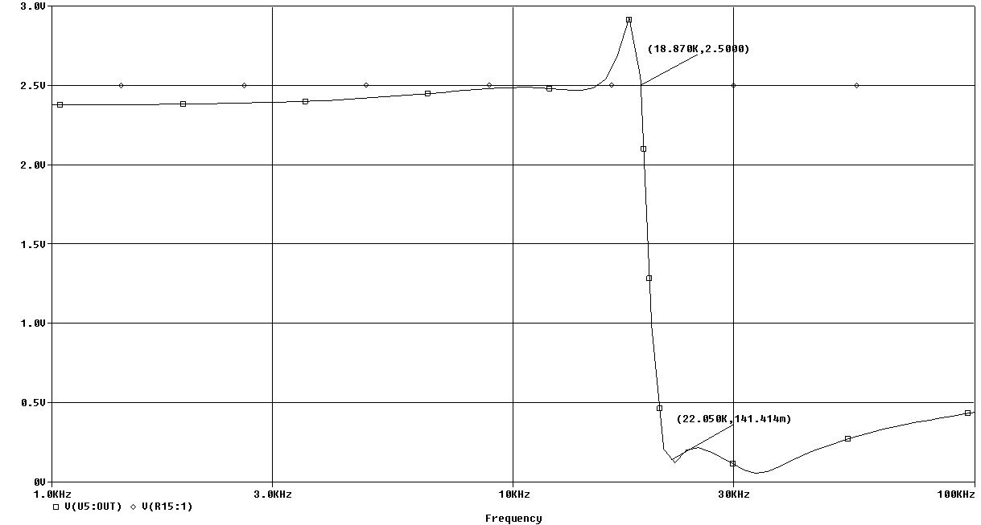
Figure 14: 2nd Iteration LPF Frequency Response

High Power Op-Amp
To find a suitable option for a High-Power Op-Amp, National Semiconductor’s (www.national.com) product list was searched, which yielded the LM1877 Dual Audio Power Amplifier. This option has the ability to output 2W into two separate 8Ω loads. This meets the design requirements, and provides more functionality for future upgrades. The cost of this part on Digi-Key (www.digikey.com) is $1.55, which qualifies as low cost. Due to National Semiconductor’s educational policy, free samples were available for students.

Speaker
To find the desired speaker, Digi-Key (www.digikey.com) was searched using the parameters of 3W at 8Ω. 3W was chosen to make sure the speaker is not overdriven. Two speakers matched these specifications, in two different sizes. The larger speaker is 90mm x 50mm and the smaller speaker is 12mm x 60mm. The smaller speaker is $6.05, while the larger speaker is $4.54. The larger speaker is chosen because of its lower cost, while still satisfying the other design specifications.

Results
The only major results from this subassembly are from the anti-aliasing filter.

Anti-Aliasing Filter
The output of the anti-aliasing filter is shown in Figure 16. The attenuation of the filter is calculated by $\text{20}\text{*log}\left(2\text{.}\text{06}/0\text{.}\text{0488}\right)=\text{32}\text{.}\text{51}\text{dB}$. The 3 dB cutoff level is at 20 kHz (when the output voltage reaches 1.26V). The layout of the filter is shown in Figure 15.
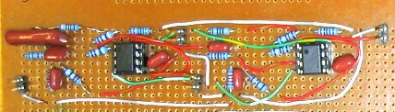
Figure 15: Anti-Aliasing Filter Layout
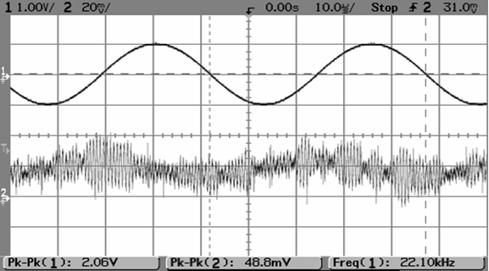
Figure 16: Anti-Aliasing Filter Results

System Definition
This section is composed of the preliminary drawing packages, assembly and component packages, the bill of materials and supplier information, and the overall specifications for the Audio Subsystem.

Drawing Packages
The drawing package is displayed throughout Chapter 3. Figure 7 is a basic block diagram of what the input audio subsystem does in total. Figure 8 is a basic block diagram of the output audio system. These figures completely represent what the audio subsystem does in this project. The blocks show the simplest functions to be performed.

Assembly and Component Packages
This section will contain the element by element schematics with the specific part numbers on each part.
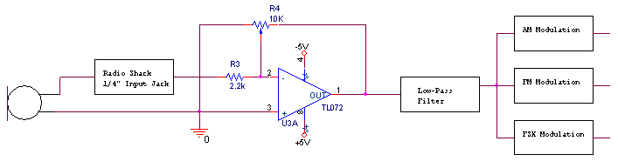
Figure 17: Audio Subsystem Circuit Diagram - Input
Figure 18: Audio Subsystem Circuit Diagram – Output

The majority of the input Audio subsystem is displayed in Figure 17. The output stage of the Audio subsystem is displayed in Figure 18. The filter block is Figure 13 and is already displayed in the previous section, with all of the necessary component part numbers and values to be used in the construction of the Audio Subsystem in the Spring Quarter 2005.

Bill of Materials and Suppliers
Table 5 shows the Bill of Materials and Suppliers for the current design.
Table 5: The Bill of Materials and Suppliers
Item | Supplier | Quantity | Cost | Part Number
Unidirectional Dynamic Microphone | Radio Shack | 1 | 19.99
1/4 inch Panel-Mount Jack | Radio Shack | 1 | 3.99
TL072 | Digikey | 10 | 6.4 | 296-1775-5-ND
Potentiometer | Digikey | 1 | 2.32 | P4F4502-ND
LM1877 High Power Op-Amp | National Semiconductor | 2 | **free**
Speaker | Digikey | 1 | 4.54 | P10186-ND
10k 1% metal film resistor | Digikey | 10 | 1.08 | 10.0KXBK-ND
316k 1% metal film resistor | Digikey | 5 | 0.54 | 316KXBK-ND
7.87k 1% metal film resistor | Digikey | 10 | 1.08 | 7.87KXBK-ND
8.06k 1% metal film resistor | Digikey | 5 | 0.54 | 8.06KXBK-ND
121k 1% metal film resistor | Digikey | 5 | 0.54 | 121KXBK-ND
130k 1% metal film resistor | Digikey | 5 | 0.54 | 130KXBK-ND
357k 1% metal film resistor | Digikey | 5 | 0.54 | 357KXBK-ND
9.09k 1% metal film resistor | Digikey | 10 | 1.08 | 9.09KXBK-ND
9.31k 1% metal film resistor | Digikey | 5 | 0.54 | 9.31KXBK-ND
15.8k 1% metal film resistor | Digikey | 5 | 0.54 | 15.8KXBK-ND
1nf cap | Digikey | 4 | 1.84 | P3102-ND
620pf cap | Digikey | 3 | 0.84 | P3681-ND
390 pf cap | Digikey | 2 | 0.56 | P3391-ND
220pf cap | Digikey | 2 | 0.56 | P3221-ND
820pf cap | Digikey | 2 | 0.56 | P3821-ND
15nf cap | Digikey | 2 | 0.56 | P3478-ND
 |  | Total | $49.72

Overall Specifications
The overall specifications are all listed in Table 6.
Table 6: Overall Specifications
 | Input | Units
Input Voltage | 0-5 | V
Input Jack | ¼ cable | -
Output Voltage | Adjustable | V
Output Jack | SMA | -

Future Improvements
The audio subassembly could be modified by different low-pass filters, allowing students to see the differences in bandwidth of the output signal when using different low pass filters. A simple RC circuit could be used as well as other more complex filters, for instance, an LC Ladder Filter or Inverse Chebyshev.

AM Subassembly
The AM subassembly is one of the three different transmission methods used in this senior design project. The AM stands for Amplitude Modulation and is a specific form of modulation. This chapter will display the concept development, feasibility assessment, design objectives and design procedure used in the Winter Quarter of 2004-2005.

Subsystem Introduction
In the AM subassembly there are 2 sections: transmit and receive. In the AM transmitter, there are 5 major blocks: the oscillator, two buffer amplifiers, the modulated amplifier, the RF power amplifier, and the antenna. The oscillator supplies the carrier wave that will be modulated by the input. The buffer amplifier and the audio amplifier are to isolate the previous blocks from the modulator. The modulator is the device that will actually mix the message signal with the carrier signal, creating the AM signal. The RF power amplifier will be used to boost the modulated signal to a level that will broadcast the signal to the receiver. The block diagram is shown in Figure 19.
The AM receiver is much simpler than the transmitter setup. An antenna receives the signal and passes it to an envelop detector that will detect the incoming signal and automatically demodulate the signal. A gain block will be placed on the end of this circuit to boost the power of the signal to a 0-5V output. The block diagram is shown in Figure 20.
Figure 19: Basic Block Diagram of AM Transmit Subsystem
Figure 20: Basic Block Diagram of AM Receive Subsystem

Concept Development
There were three major ideas when choosing the method for the AM subsystem was broached: a discrete parts design, separate integrated circuits (ICs), or a transceiver IC. The following concepts are discussed in this section, as well as the receiver circuit. Once one of these methods is chosen, the rest of the blocks are designed to fit in with the chosen method.

Discrete Parts Design
To do a design of an AM modulator using discrete parts, a large knowledge of analog circuit design is required. There are a number of textbooks available in the library, as well as designs on the internet that would be able to help. Some of the positives to using this style of AM transmission include the increased knowledge of how to design analog circuits for non-ideal situations and the cost. The cost of a number of discrete parts usually will be less than that of a few ICs or one transceiver IC. A drawback is that troubleshooting the circuitry, if something does not work properly, will be extraordinarily difficult. Another advantage of using a discrete part design is the ability to design the circuit for whatever frequency is desired.

Separate Integrated Circuits
There are advantages and disadvantages to using many different ICs in the AM transmitter circuitry. One of the advantages is the ease of finding separate ICs to perform the specific task. An IC that just does mixing and another IC that just does RF power amplifying is much easier to find than one IC that will do both. Especially since AM transistor radios are more than 30 years old, the ability to find parts to specifically create an AM radio is getting more difficult. The demand has gone down for AM radio ICs because FM dominates the radio market. An advantage of the separate IC design method is the easy visualization of the block diagram on the circuit board after the layout is complete. The ability to closely control the output of the system is an advantage of the separate IC method of design. A disadvantage is the external circuitry required to make many IC work according to their specifications. Most datasheets include sample circuitry, but the circuits are often incomplete, un-updated, or contains incorrect component values. The ability to choose one IC over another when there is a myriad of choices is difficult. The knowledge of superior characteristics for a specific part is quite esoteric. The differences between three ICs from three different companies are slight and choosing the one to fit into the project is difficult.

Transceiver Integrated Circuit
An AM Transceiver IC combines all parts of the AM transmitter set into one IC, with enough power to output a signal across a laboratory. An advantage of this IC is the lack of connections to other ICs and the troubleshooting that goes with this. With all functions performed in this chip, the size of the final board could be much smaller. Another advantage of this option is the lack of design choices to overload the design process. With specified input and output requirements, the input and output systems have detailed design goals. The largest advantage of the AM Transceiver IC is that the receiver chip would already be selected and its functionality with the transmitter is assured. The only AM Transceiver on the market currently is the MC13190, which operates at 2.4 GHz. With current market trends, the design experience of dealing with S-Band is highly desirable. The largest disadvantage of the AM Transceiver is the need for a surface mount PCB board. The cost of producing the board is high as well as time consuming for the designer. The required skill for soldering a surface mount IC is quite high and needs very small solder joints.

Receiver Circuit
There are three major methods to deal with the reception and demodulation of the AM signal. Discrete Components, a Receiver IC and the receive part of the Transceiver IC. The receiver part of the Transceiver is discussed in section 4.2.3. The discrete components can be made easily and designed easily, but the function of such an easy circuit is in question. The only demodulator circuit available in the textbooks consulted is the basic envelope detector, shown in Figure 21. A disadvantage of the Receiver IC is the lack of availability due to the popularity of FM. The advantages of the IC are the ease of use and the guarantee that they work when properly arranged. A disadvantage is the possible difficulty in properly arranging the supporting circuitry.
Figure 21: Envelope Detector

Feasibility Assessment
The choices laid out in section 4.2 each have their advantages and disadvantages, but using a weighted comparison method, the best choice is easily found.

AM Transmitter Subsystem
Due to the weighting of the completion by May design objective, the choice for the AM Transmitter Subsystem is the separate ICs. The ability to find parts for this method is much more secure than the other two options. The chance of free samples is quite high for many of the parts, in a ploy by the semiconductor companies to increase their business for production level designs. The disadvantages will be overcome using design choices. The disadvantage of too much external circuitry will be overcome by choosing ICs that require little or none external circuitry. Finding these parts can be difficult, but the effort at the outset pays out when the circuit is being constructed. Choosing between parts that are very similar will be done with the help of an experienced engineer.

AM Receiver Subsystem
Since the AM Transmitter is chosen as using separate ICs, choosing the Receiver circuit to match is a logical selection. There is the possibility to test, for added understanding, the envelope detector if the project is nearing completion well before the end of the quarter. However, the Receiver IC is not posted in a theoretical textbook, but is known to work correctly. The IC will be chosen to minimize the external circuitry necessary. A small company in Rhode Island has been found to sell AM Receiver ICs, overwhelming the disadvantage of finding AM Receivers.

Design Objectives
This section will give the design objectives for each of the blocks necessary for the successful completion of the AM Transmitter and Receiver. The blocks for the transmitter include: a clock oscillator, buffer amplifiers, modulator, power amplifier, and antenna. The receiver blocks include an antenna and an AM receiver.

Clock Oscillator
The clock oscillator is the component in the AM circuitry that will supply the carrier signal to the rest of the module. The output needs to be at least an approximation of a sine wave for proper AM modulation. The frequency of this component is the determining frequency for the rest of the AM system. The AM modulation can be done on any frequency; standard AM broadcast frequencies are 530 kHz to 1700 kHz. For this reason, the frequency is chosen at 1 MHz (1000 kHz). At 1 MHz, the frequency band in Rochester, NY (the operational location) is relatively clear, thus leading to less interference. Low-cost option is a desire.

Buffer Amplifiers
The output for the clock oscillator will be disturbed by the input impedance of the modulation block, so the oscillator will need to be buffered by a unity gain amplifier. The use of a buffer amplifier on the audio input is twofold; to be sure the input resistance does not interfere with the operation of the audio subsystem and to assure proper modulation levels. The gain of this block will probably be less than 1, just to guarantee the circuit does not over modulate.

Modulator
The modulator for the AM system needs to be able to modulate the carrier and the message signals into a correct AM signal. The input voltage levels will be a maximum 0-5V for both signals, with the message signal being a bit lower than the carrier signal. This IC should be able to output a signal that can be increased by a power amplifier to be broadcast across the laboratory. The minimum amount of external circuitry is a priority. Low-cost is a desire for the design.

Power Amplifier
The design of the power amplifier relies greatly on the choice of the modulator. The output voltage of the amplifier should be no more than 4 dBm or 2.4 mW. This amount of power is more than enough to go up to 10 meters and beyond. The IC should be able to accept anything the modulator can output. The bandwidth of the IC should be high to accommodate signals with a lot of information. The output of the power amplifier will go to an SMA connector.

Antenna
The antenna for the AM Transmitter and Receiver will be the same antenna for each side. AM frequencies do not require large antennas in general. The connector on the antenna must be SMA for easy analysis by students who will be the end users of this product.

AM Receiver
An AM receiver must be able to operate at the frequency chosen for the circuit, as well as have enough sensitivity to detect the input signal. The part should be available in United States for a reasonable price.

Design Synthesis
This section is an in depth look at the design process for the AM Transmitter and Receiver. The blocks covered are the Clock Oscillator, the Buffer Amplifiers, the Modulator, the Power Amplifier, the Antennas, and the AM receiver.

Clock Oscillator
There are two main options for an oscillator: Clock oscillator or a Crystal oscillator. The first specification is a 1 MHz signal. Looking at Digi-Key, (www.digikey.com) there is a selection of both crystal and clock oscillators at the design frequency. The next specification is the sine wave. At a first look, the crystal oscillator is the best option, because it has a steady output of a sine wave. The clock oscillator has a pulsed output. However, the pulsed output can be changed into an approximate sine wave using a simple L-C filter. The third specification is price. The crystal oscillator at this frequency cost $17.88, while the clock oscillator cost $1.88. In this category, the clock oscillator is a clear winner. As a bonus, the clock oscillator is a much easier component to use, with only 4 pins going to the PC board. The crystal oscillator needs supporting circuitry to fully operate as designed. Figure 22 shows the clock oscillator and the RLC filter over 10 periods.
Figure 22: Clock Oscillator and RLC Filter

Buffer Amplifiers
The buffer amplifiers are very similar to the Op-Amp in section 3.5.2. The main difference is the potentiometer. The amplifiers in the AM Transmitter is not going to need to be manually controlled. The unity gain amplifier will have equal values for each resistor at 10 kΩ. The modulation factor (depth of modulation) needs to be picked to design for the audio buffer amplifier. To have the maximum power transmitted to the receiver in a double sideband transmission, the m should be equal to 1. However, if the value of m is higher than 1, the signal is over modulated and data is lost. To be guaranteed that m is not greater than 1 at any time, the modulation factor should be equal to 0.8. The depth of modulation is equal to the voltage of the message divided by the voltage of the carrier signal. The voltage of the carrier supply is 2.4 V from the clock oscillator. Therefore, the voltage from the message should be equal to 0.8 times 2.4V. This works out to 1.92V. The resistor values should work out to be approximately a ratio of 2 to 5. Resistor values that fit that specification are 8.2 kΩ and 22 kΩ.

Modulators
Finding an AM modulator is a difficult process of searching different semiconductor company’s websites looking for a part that may or may not be made anymore. The MC13175 was found on the same website as the AM receiver. The sample diagram in the datasheet is for a 320 MHz AM Transmitter, which is a much higher transmit frequency than desired. The circuit also uses a loop antenna and a 50Ω balun. The use of crystal oscillators also increases the difficulty of implementation, due to the exacting tolerances for resistors and capacitors. The MC13175 was rejected for these reasons. While looking for AM Receivers, a TDA part was found, so following that lead, a TDA AM Modulator was searched for on the Philips Semiconductor website. Unfortunately, a TDA AM modulator does not seem to exist. The next semiconductor website searched was ON Semiconductor. This search yielded the MC1496 Balanced Modulator/Demodulator. Looking through the datasheet, this IC appears do be able to function successfully. A figure in the datasheet is an example AM Modulator circuit, possibly making the functional design easier. However, the previously noticed disadvantage of incomplete or wrong sample diagrams seems to be true in this circuit. To assist in the choosing of a modulation IC, a senior analog design engineer was contacted and queried. The recommendation was to use an analog mixer from Analog Devices, specifically one of the model numbers AD633 or AD835. After looking at the datasheets for each, the AD835 was selected. The superior bandwidth and supply voltages both counted in its favor. The cost was not a factor because Analog Devices is another company that will send a few sample ICs to assist in the design and testing of circuits.

RF Power Amplifier
The design for the RF Power Amplifier is chosen to be an Analog Devices part, to match the modulation unit. The original part chosen is the AD621. The problem with this IC is the bandwidth is too limited. An 800 kHz bandwidth may be enough, but there are better power amplifiers. After consulting with the senior analog design engineer, the AD8056 was recommended through good personal experience. The bandwidth for the AD8056 is a much larger 300 MHz. The implementation is just like a High Power Op-Amp. With an output of 60mA and 40V, the design objective of 2.4 mW is easily reached.

Antennas
AM antennas are not difficult to design at a frequency of 1 MHz. Approximately 30 inches of wire is enough to radiate the signal and retrieve it at the receive side. The antenna needs to be attached to a SMA connector, for ease of analysis by future students.

AM Receiver
To find a suitable AM receiver there was a large amount of searching company web pages. Each of the large semiconductor companies (Motorola www.motorola.com, Freescale Semiconductor www.freescale.com, National Semiconductor www.national.com, ON Semiconductor www.onsemi.com, Fairchild Semiconductor www.fairchildsemi.com, and Maxim www.maxim-ic.com) were queried for their own AM receiver. However, each of these companies since the late 80’s, has not fabricated any AM receivers because of the competition from the Far East. Using Google, an AM receiver was mentioned; this is the TDA 1072 made by Philips. A search was performed to find a data sheet and a seller of the TDA 1072. The data sheet was found, with a copyright of 1987, but there was only one American seller. This obsolete IC dealer would not bid on selling his TDA 1072 stock. A search was then made of the Philips semiconductor website, which revealed another AM receiver which is in current production. The TDA1572T is in full production, but after searching, the possibility of purchase does not exist. Only two American dealers had the TDA1572t available for purchase, but both prominently displayed messages stating their requirement for $100 minimum purchases. On a small electronics company’s site, another AM receiver was found. The ZN416E is an AM receiver fabricated by a company called GEC Plessey Semiconductors. The operating range for this component is 15 kHz to 3 MHz, within which the 1 MHz design frequency falls. Most importantly, the part is available for purchase within North America.

Results
This section contains the results from each part of the AM system, as well as the overall results.

Clock Oscillator/ RLC Filter
Figure 23 shows the input and output of the RLC filter. Input 2 is the input clock signal with a peak-to-peak voltage of 4V. Input 1 is the output of the RLC filter with a peak-to-peak voltage of 5V.
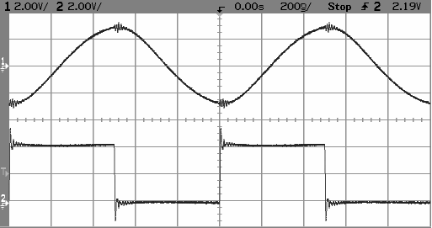
Figure 23: RLC Filter

Audio Input Buffer
Figure 24 shows the input and output of the audio buffer that is shown in Figure 26. The input, in this case, a 1kHz sine wave, is unchanged in phase, but the amplitude of the output has been decreased by approximately 4 to allow input into the mixer.
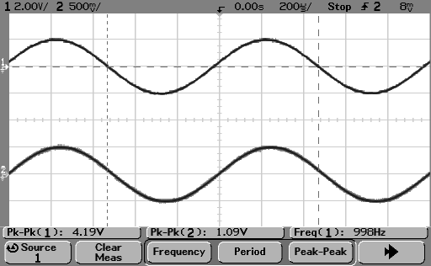
Figure 24: Audio Input Buffer

AM Modulation
At the time of this printing, there laboratory data for the AM modulation section.

System Definitions
This section is composed of the preliminary drawing packages, assembly and component packages, the bill of materials and supplier information, and the overall specifications for the AM Transmitter and Receiver Subsystems.

Drawing Packages
The basic block diagrams for the AM subsystem are shown in Figure 19 and Figure 20. These two diagrams effectively show the overall subsystem clearly.

Assembly and Component Packages
This section will contain the element by element schematics with the specific part numbers on each part.
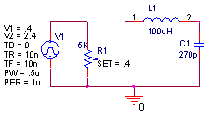
Figure 25: Clock Oscillator and Buffer Amplifier
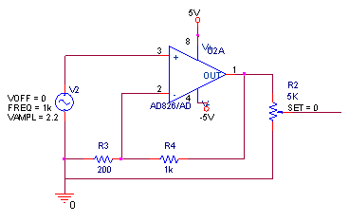
Figure 26: Audio Input Buffer
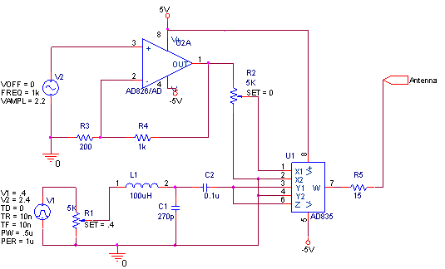
Figure 27: Mixer, RF Amplifier, and Antenna
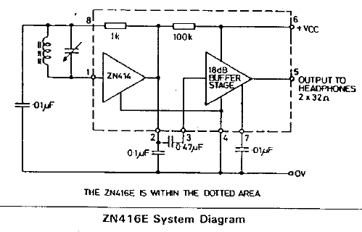
Figure 28: Antenna and AM Receiver

Bill of Materials and Suppliers
Table 7 shows the Bill of Materials and Suppliers for the current design.
Table 7: Bill of Materials and Suppliers
Item | Supplier | Quantity | Cost |  | Part Number
AD835 | Analog Devices | 1 | 8.90 | *free* | AD835AN
ZN416E | Ocean State Electronics | 1 | 10.95 |  | ZN416E
AD826 | Digikey | 1 | 4.97 | *free* | AD826AN-ND
10k 1% metal film resistor | Digikey | 5 | 0.54 |  | 10.0KXBK-ND
15k 1% metal film resistor | Digikey | 5 | 0.54 |  | 15.0KXBK-ND
680 1% metal film resistor | Digikey | 5 | 0.54 |  | 680XBK-ND
100uH Inductor | Digikey | 1 | 0.54 |  | M7837-ND
270 pF Capacitor | Digikey | 1 | 3.36 |  | P3271-ND
0.1uF Capacitor | Digikey | 4 | 0.34 |  | P3104-ND
0.47uF Capacitor | Digikey | 1 | 0.83 |  | P3474-ND
1 MHz Oscillator | Digikey | 1 | 1.88 |  | X101-ND
5k Potientiometer | Radio Shack | 2 | 2.89

Overall Specifications
The overall specifications are all listed in Table 8.

Table 8: Overall Specifications
 | Value | Units
Input Voltage | 0-5 | V
Input Jack | .1” header | -
Max Output Voltage | +4 | dBm
Output Jack | SMA | -

Future Improvements
There is one major area by which the AM subassembly can be improved: the writing of laboratory experiments.

Laboratory Experiments
There are multiple experiments that can be performed using this laboratory equipment. On an oscilloscope or a spectrum analyzer, the results of different modulation indexes can be observed. The changes in modulation indexes are easily accomplished using the potentiometers that are designed into the circuit. At the receiver, the input signals can be analyzed to see the differences in the modulation index. The audio output will allow students to hear the sound errors that result from over-modulation. Students could measure the channel losses of the AM signal.

FM Subassemblies
This section includes the development of both the FM transmitter and receiver sections. These systems are defined in sections 2.3.1.5 and 2.3.1.6.

Conceptual Design
Frequency Modulation is a form of modulation where the frequency of the carrier signal is varied in proportion with the message signal. When no message is being conveyed, the carrier frequency stays at a constant value (say 100MHz). To send a message on the carrier using frequency modulation, the frequency of the carrier is changes proportionally with the amplitude of the message signal. Figure 29 shows an example of a carrier modulated by a message signal.
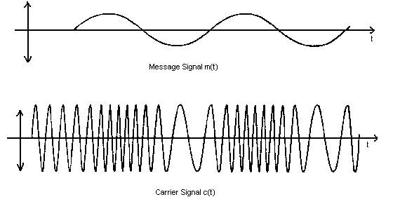
Figure 29 – Frequency Modulation of a Carrier

The equation for a frequency modulated signal shows the message signal added to the frequency of the carrier. That is:
$$\text{v }={\text{ a}}_{c}\text{ sin}\left(ω_{c}+\text{ m sin}\left(ω_{m}t\right)\right)$$
The fundamental building blocks of an FM transmitter and receiver can be found in Figure 30 and Figure 31.
Figure 30 – Basic FM Transmitter

Figure 31 – Basic Superheterodyne FM Receiver

Preliminary Feasibility Assessment
It takes a great deal of time and knowledge to engineer a stable and reliable FM transmitting and receiving system as outlined in section 5.1. In industry, an experienced engineer can take months planning, designing, building, and refining similar systems. This team only has one engineer assigned to these systems and his time is divided between the FM and FSK tasks. Therefore it would not be feasible to design the above systems from scratch.

Concept Development
The simplest solution would be a mixed signal IC. There is a range of IC available which contain all the necessary building blocks for a stable and reliable RF system. They include the necessary amplifiers, oscillators, modulators, demodulators (PLL’s), mixers, and other pieces. Sometimes the only external parts necessary are RF loop and front end filters.
A set of objectives were formulated for selecting a mixed signal IC. The objectives were then weighted based on their importance for performance and feasibility. They are outlines in Table 9.
Objective | Weight
Part availability | 10
Comprehensive design resources | 8
Application examples | 7
Performance | 6
Price | 5
Low parts count | 5
Table 9 – Analog FM Part Selection Objectives
Next, a verity of popular mixed signal IC’s were research and they were rated (from 0 to 10) based on compatibility with the objectives in Table 9. The scores were then multiplied by the weights of the objectives and tabulated. This analysis can be found in Table 10.
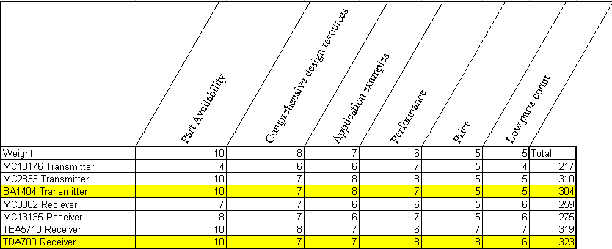
Table 10 – Analog FM Part Analysis
The BA1404 Transmitter is the current choice for FM broadcast. It is widely used, has many application examples and is currently available for sale for only $6.95 from Ocean State Electronics.
The TDA7000 has been chosen as a receiver. This chip also has many documented examples and is currently available for sale for only $9.95 from Ocean State Electronics.

Feasibility Assessment
Before major development began a feasibility assessment was performed. This involved estimating the time reach major design task would require. A system time budget can be found in Table 2 showing the estimated time and actual time required for completion.

Task | Estimated Time in Hours | Actual time in Hours
Schematic Creation | 15 | 12
Performance Analysis | 5 | 5
Specification Formation | 13 | 10
Parts List | 8 | 10
General Documentation | 10 | 11
Board Layout | 12 | 15
Board assembly | 7 | 6
Functional Test | 12 | 8
Integration | 4 | 4
Tweaking and Repair | 20 | 10
Total | 106 | 91
Table 11 – Analog FM Time Budget

The subassembly was completed in less time then estimated.

Target Specifications
The main specification for the FM transmitter and receiver is that they are able to work as a pair at a max distance of no less than 10 meters (in addition to the integration requirements set section ). The design constraints are purposefully few in number to allow the designing engineer flexibility. This way basic functionality and project achievability are maintained.

Design Documents
The next step in the design process was to create the necessary design documentation. First a set of schematics and parts lists were created. Voltage regulators, amplifier, and resistor networks for audio attenuation were designed and various parts in the assemblies were integrated. Design specifics can be found in the engineering notebooks. Next specification documents were created which outline the expected performance of the assemblies. These specifications are not design constraints, yet merely expected performance parameters and operating conditions. Interconnection Control Documents were also created. These documents outline all the connectors on the assemblies, what they do, and state relative voltage, power, and signal limitations. Also, a Printed Circuit Board (PCB) layout was developed so that functional units could be built. A PCB is necessary in most RF applications because they eliminate problems of poor connections and parasitic impedances usually found in bread boards and prototype boards. Finally, a set of Test Procedures were created so the units could be tested for their functionality. These documents can be found in Appendix B.

Design Synthesis

The PCBs were purchased and the circuits were assembled in RIT’s Center of Integrated Manufacturing. Execution of the test procedures reviled few problems and design changes were minimal.
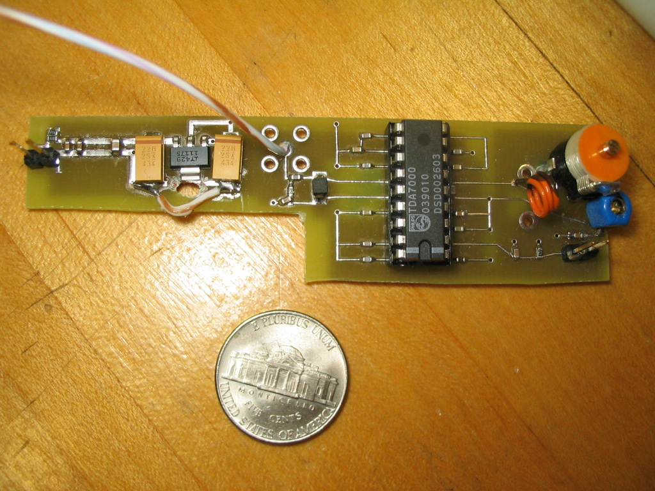
Figure 32 – FM Receiver Board
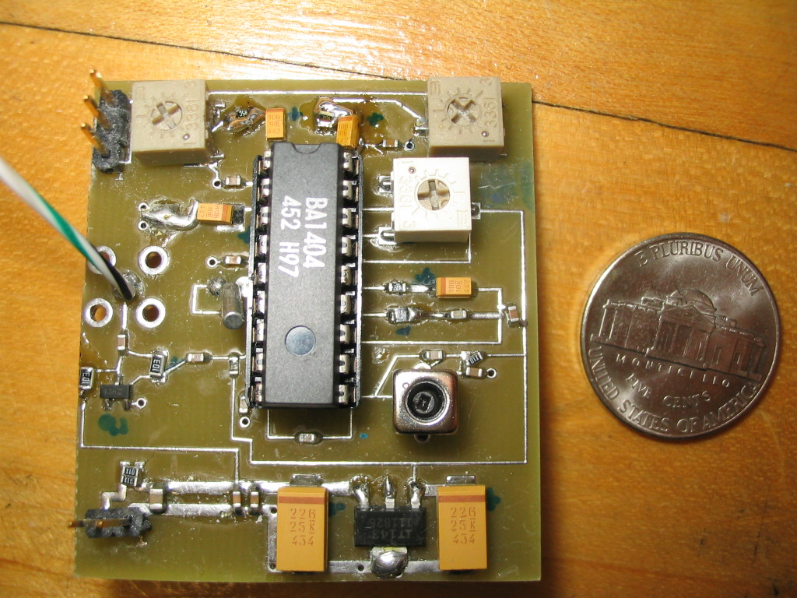
Figure 33 – FM Transmitter Board

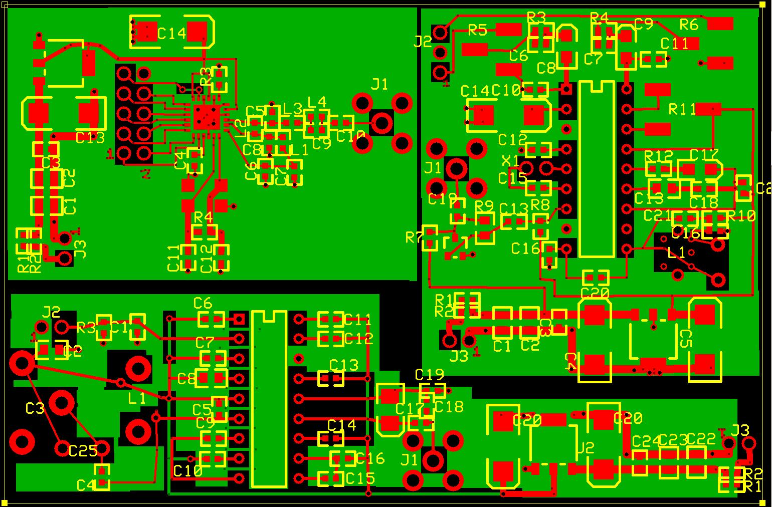
Figure 34 – Board Layout for FM Transmitter, FM Receiver, and FSK Transceiver

Design Issue (PCB Short)

A short was found between two traces on the PCB. The problem was remedied by grinding the trace with a grinding tool and the problem was fixed in documentation to eliminate the problem on future boards.
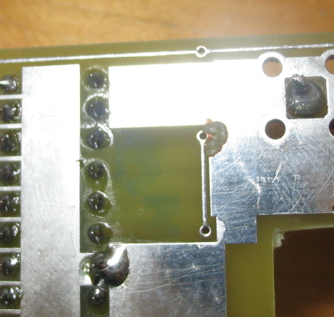
Figure 35 – Short Removed from Board

Design Issue (Voltage Regulator Pin-Out)

The redundant forth pin on two of the voltage regulators was mistakenly assumed to be ground when it was actually VCC. This problem was again remedied by grinding a trace and updating the documentation

Design Issue (Tuning Capacitor)

It was found that the variable capacitor used for receiver tuning was too coarse. A smaller capacitor was added in parallel to act as a fine adjustment. This capacitor can be seen as C25 on the receiver board.

Design Issue (Audio Distortion)

There was significant amount of audio distortion resulting from the pre-emphasis stage of the transmitter. It was found that the load of the modulator input was affecting the response of the pre-emphasis stage and causing distortion. The solution was to move the pre-emphasis stage from the FM transmitter board and to the gain block.

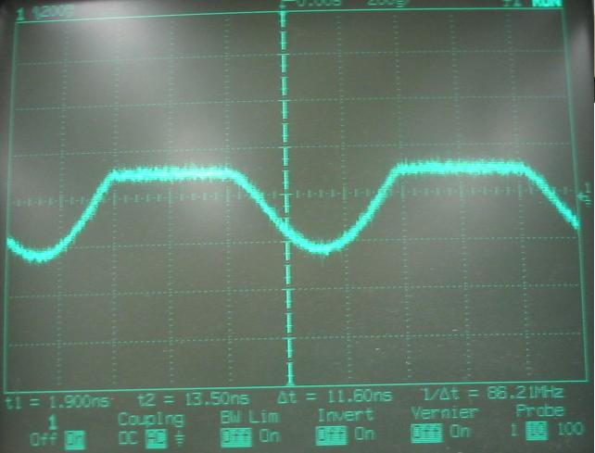
Figure 36 – Input Audio with Distortion Problem

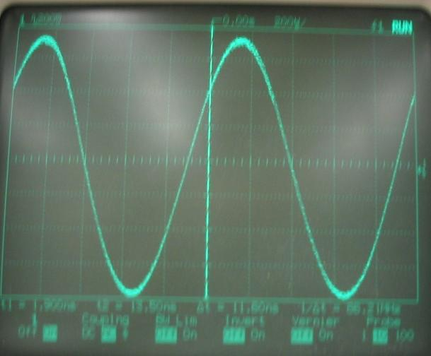
Figure 37 – Input Audio after Resolution of Distortion Problem

Design Issue (Tuning Inductor)

Finally, the variable inductor used for tuning the transmitter was too small. A few winds of wire were added to boost the inductance such that the oscillator could reach broadcast frequencies.
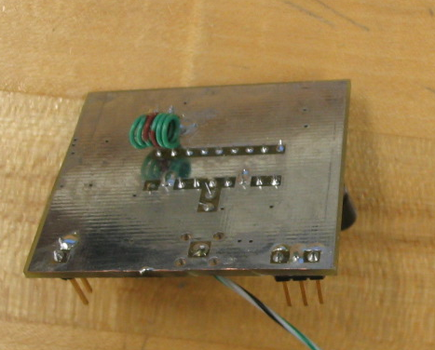
Figure 38 – Added Inductance to Back of FM Transmitter

Unit Testing

After the design changes were implemented, the units were tested in accordance to their test procedures (see appendix B). First they were tested for individual functionality and then as a system. They are capable of transmitting and receive clear audio over of 10 meters. Thus the FM transmitter and receiver are considered to be fully functional at the time of this report.

FSK Subassembly
This section includes the development of both the FSK transmitter and receiver subsystems. These systems are defined in sections 2.3.1.7 and 2.3.1.8.

Preliminary Feasibility Assessment
The feasibility assessment for the FSK section is similar to that of the FM section. Designing an FSK would be just as difficult if not more so. An FSK system would contain many of the same types of systems (amplifiers, oscillators, mixers, modulators, detectors, etc). Likewise, it would not be feasible to design the aforementioned systems from scratch.

Concept Development
Similar to that of the FM device, the objective is to choose a mixed signal IC which contains the necessary components for FSK transmitting and receiving. There are a range of ICs available with this criterion.
A set of objectives were formulated for selecting a mixed signal IC. The objectives were then weighted based on their importance in terms of performance and feasibility. They are outlines in Table 12.

Objective | Weight
Part availability | 10
Comprehensive design resources | 8
Application examples | 7
Performance | 6
Price | 5
Low parts count | 5
Table 12 – FSK Part Selection Objectives
Next, a verity of popular mixed signal IC’s were researched and they were rated (from 0 to 10) based on compatibility with the objectives in Table 12. The scores were then multiplied by the weights of the objectives and tabulated. This analysis can be found in Table 13.
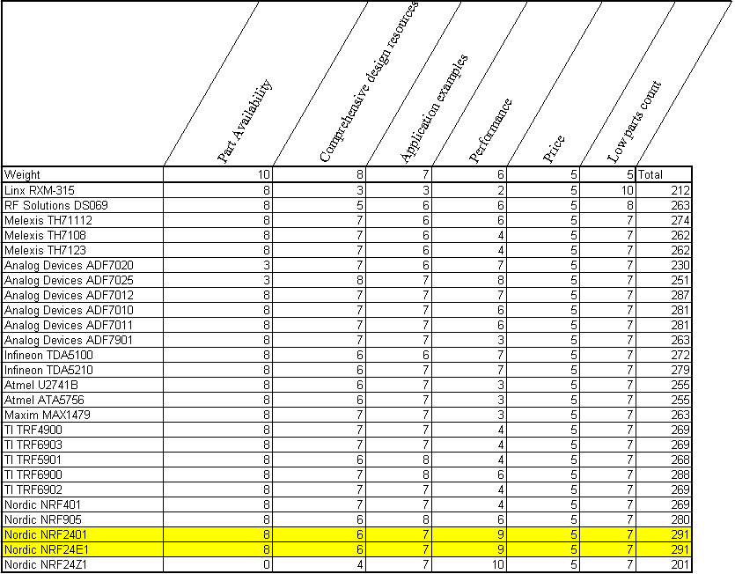
Table 13 – FSK Part Analysis
There is a correlation with regards to carrier frequency and bit-rate. A 2.4GHz channel will be harder to implement but yields a much higher bit-rate. The NRF24E1 2.4GHz Nordic chip is an industry leader and there are many support document and design examples. Additionally it meets our data-rate desires, and operates at the same frequency as a previous communications project. Thus the NRF2401 is a good choice (the NRF24E1 is essentially the same part as the NRF2401 however; it offers a microcontroller which we do not need). Furthermore, the NRF2401 is a transceiver which means a separate transmitter and receiver need not be developed.

Feasibility Assessment
Again, a subsystem time budget is performed to assess feasibility. This involved estimating the time each major design task would require. A system time budget can be found in Table 14Table 2 showing the estimated time and actual time required for completion.

Task | Estimated Time in Hours | Actual time in Hours
Part Research | 8 | 10
Schematic Creation | 7 | 7
Performance Analysis | 5 | 2
Specification Formation | 8 | 5
Parts List | 8 | 7
Timing Information | 10 | 8
Board Layout | 12 | 15
Board assembly | 7 | 6
Functional Test | 13 | 12
Integration | 15 | 20
Tweaking and Repair | 20 | 4
Total | 113 | 96
Table 14 - FSK Time Budget

The FSK system was completed within the estimated time.

Target Specifications
Based in the parts used in the design, the following subsystem specifications were developed.
Parameter | Value | Tolerance | Units
Supply Voltage | 4 to 15 | - | V
Current Draw | 10 | +/-5 | mA
Operating Temperature | -40 to +85 | - | °C
High level input | VDD | +/-.3 | V
Low level input | VSS | +/-.3 | V
High level output | VDD | +/-.3 | V
Low level output | VSS | +/-.3 | V
Frequency Deviation | +/-156 |  | kHz
Data Rate (ShockBurst) | <0 to 1000 |  | kbps
Data Rate (Direct) | 250 or 1000 |  | kbps
Channel Spacing | 1 |  | MHz
Sensitivity (.1% BER, 250kbps) | -90 | +/-3 | dBm
Sensitivity (.1% BER, 1Mbps) | -80 | +/-3 | dBm
Max power output | 0 | +/-3 | dBm
Table 15 – FSK Transceiver Preliminary Specification

These are not design constraints; they are estimated performance specifications from which requirement conformance can be determined. Using these specifications, general conformance to system requirements can be verified. Given the standard attenuation of an RF signal through space, there will be a 60dB loss over a distance of 10meters. With an output power of 0dBm at the transmitter, the received power will be -60dBm. This is well within the -80dBm sensitivity of the receiver. Furthermore, both receive and transmit antennas have 9dB of antenna gain. This gives almost 40dB of positive overhead in the area of signal strength.

Design Documents

Much like that of the FM system; schematics, parts lists, specification documents, interconnection control documents, PCB layout’s, and test procedures were created. Additionally, an FSK Protocol document was created to describe the way data must be sent to the device. Design specifics can be found in the engineering notebooks and the documents can be found in Appendix B.

Design Synthesis

The PCBs were purchased and the circuits were assembled in RIT’s Center of Integrated Manufacturing.
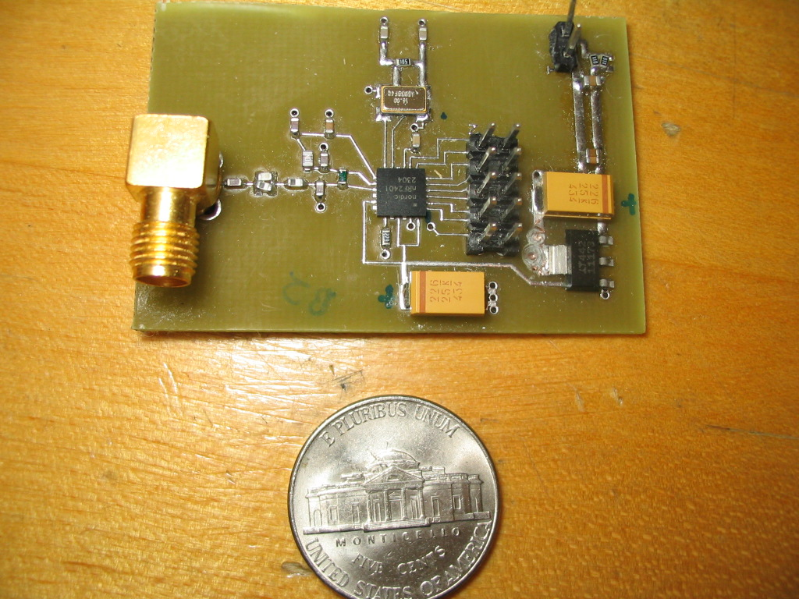
Figure 39 – FSK Transceiver Board

Execution of the test procedures reviled no problems and no design changes were necessary. The transceivers are capable of sending information over a distance of 10 meters at a rate of 1mbps. The FSK transceivers are considered to be fully functional at the time of this report. The bulk of the work necessary to implement streaming audio resides in the digital control and coding.

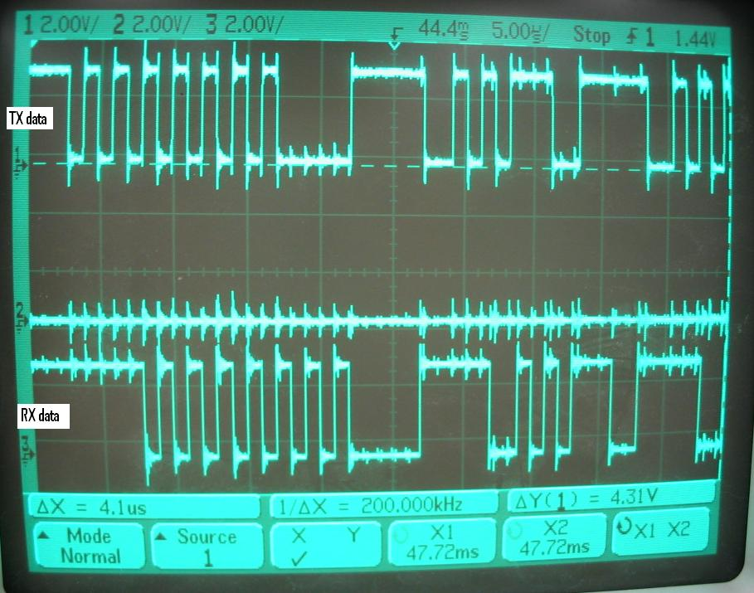
Figure 40 – Capture of Transmitted and Received Data

Digital Processing and Control Subsystem

Subsystem Introduction
The digital processing and control subsystem consists of a microcontroller only on the transmit side, and on the receive side it consists of a microcontroller and a Digital to Analog Converter (DAC). The purpose of this system is to:
- Convert an analog signal into digital data using pulse code modulation
- Provide data flow and management between the microprocessor and the FSK transceiver
- Convert the transmitted PCM signal back into an analog signal
A final block diagram of the transmit and receiver portions of this subassembly are shown below inside the dashed line in Figure 41.
Figure 41 – Digital Processing and Control Subsystem Block Diagram
The analog signal shown in the figure is the output from the Audio Subassembly. The microcontroller performs the analog to digital PCM encoding. This signal is then sent to the FSK transceiver which transmits over RF to the other transceiver. The microcontroller on the receive side receives the data from the FSK chip and sends it to the DAC. The DAC outputs an analog signal similar to that of the input signal.
This chapter will discuss in detail each operation this subsystem performs to get the signal from analog to a PCM encoded bit stream and back to analog.

Concept Development
The implementation of PCM is a very common process and therefore it was not hard to find means of performing this operation. This section develops the design process for implementing this base-band modulation technique and also discusses ideas created throughout the process that were rejected for preliminary design.
The analog signal must be PCM encoded by a sampling and encoding process. This process is known as analog to digital conversion. There are many different analog to digital converters on the market and it is essential to choose the right one to meet the needs of the project. After several revisions, the PIC18LF2525 was chosen because it is a cheap solution for analog to digital conversion. Also, the PIC microcontroller provides the ability to process the digital data for encoding as well as provide control to other parts of the project such as simultaneously sending data to the DAC with the MSSP (Master Synchronous Serial Port).

Design Considerations
In order to design a communications system, there are many fundamental concepts that must be understood before attempting this heroic task. Here the fundamental concepts of PCM encoding are discussed in order to show the parameters that define the design process.
Sampling
The first step to convert the analog signal to a digital Pulse Code Modulated signal is to sample. Sampling is the process of recording the level of voltage at a specific time. The sampling process can be mathematically represented by an impulse train as given below.
The important parameter here is T_{s}, which is the sampling period. By the Nyquist criterion this sampling frequency should be greater than twice the highest frequency in the signal.
The Nyquist criterion defines the necessary sampling frequency to prevent aliasing. Aliasing is the overlapping of frequencies after sampling. Below is the mathematical representation of sampling an analog signal x(t).
Taking the Fourier transform of both sides will reveal the frequency spectrum of the sampled signal. The frequency domain of the impulse function signal is given as,
where f_{s} = 1/T_{s}.
Since multiplication in the time domain is convolution in the frequency domain, the sampled spectrum is given as,
Convolution of an impulse function with another function simply shifts the original function as follows,
Therefore the transform of the sampled waveform is:
(7.1)
Equation 7.1 reveals that the frequency spectrum of a time sampled signal is actually just the frequency spectrum of the signal repeated every f_{s} Hz. Figure 42 below shows a theoretical spectrum of an analog signal.
Figure 42 - Spectrum of original signal
Figure 4 shows the sampled spectrum.
Figure 43 - Frequency Spectrum of Sampled Signal
It is clear from Figure 4 why Shannon’s sampling theorem is important. Figure 4 reveals visually the problem with having a sampling frequency, f_{s} < 2f_{m}. If this is true the frequencies will overlap causing ‘aliasing’ or interference.
For this project it is desired to have the ability to transmit any audio signal, including music from any source. Therefore it was chosen to design for a bandwidth of 20 kHz at the input. This is the generally accepted range of frequencies the human ear can hear. In most high fidelity audio applications, such as a compact disk, audio is PCM encoded with a sampling frequency of 44.1 kHz. This frequency clearly satisfies the Nyquist theorem for a 20 kHz signal. Therefore in this project it was decided to sample at approximately 44.1 kHz.
Quantization
Now that specific voltage samples are taken, they must be encoded to a binary word representing that voltage value. Quantization is simply the dividing of the peak-to-peak voltage (V_{pp}) of the analog signal by a certain number of levels L. The higher the number of levels the more accurate the sample is. Figure 5 shows this process.
Figure 44 - Quantization of an analog signal into L levels
The voltage levels are designated by horizontal cross sections; the samples are represented by the vertical lines that intersect the signal. Clearly the sampled voltages may not correspond to a specific voltage level (V_{ss}+V_{pp}/L*n; where n is quantization level) in the quantization. Therefore some rounding must occur. The more levels there are the more accurate each sample will be since there will be less rounding error.
After each sample is correlated to each nearest voltage level, L, a corresponding binary word representation is assigned. The lowest voltage value is given by 0 binary and the highest voltage value (V_{dd}) as 2^L in binary. To represent L voltage levels it requires n = log₂ L bits. Therefore the higher the sample size the better resolution of the sample. Quantization noise is the error caused by rounding. The signal to noise ratio in dB for an n-bit sample of the quantization process is given by,
This shows that each additional bit increases the SNR by 6dB. The tradeoff in having a higher resolution AD converter is the need for a higher bandwidth.
PCM Encoding Format
It is known that PCM encoding results in a bit stream of n-bit samples, however, the format is important. There are many PCM waveform schemes such as NRZ, RZ, unipolar-NRZ, etc. Typical AD converters output a signal where a binary ‘1’ in the bit stream corresponds to the highest voltage supplied to the chip, V_{dd}, and a binary ‘0’ corresponds to a voltage low, V_{ss}, which is typically –V_{dd} or 0V. This PCM waveform is known as NRZ-L.
The PCM waveform is very important to the design because it determines the bit rate necessary of the system, the ability to transmit the signal wirelessly, and the type of modulation used to transmit the signal over RF. The PCM waveform also will affect the bandwidth and the shape of the frequency spectrum of the signal.
Other important factors in PCM encoding are the resolution and throughput. The resolution defines how many bits per sample are taken and the throughput defines the data rate for which the samples should be sent out of the system. Both factors affect your required transmission bandwidth, given by, where B is the bandwidth required of the RF system, n is the resolution of the PCM signal, and f is the sampling frequency.
Digital to Analog Conversion
On the receive side the process of converting each digital PCM code sample must be reversed. A digital to analog converter takes each n-bit sample and converts it into the corresponding voltage, V_{out} = V_{ss}+V_{pp}/L*n; where n is the quantization level. After this stage a low pass filter should be employed to cut out any higher frequencies than the message signal contains.

Choosing Components
Microprocessor
The components for this system were initially chosen on the basis of design requirements. It was decided first that a PICmicro microcontroller would be used to provide AD conversion. This decision was based on the AD capability, the required sample rate being met, the cost, and the availability. Also it was thought some encoding format would be applied by the PIC, until it was decided to go with the standard NRZ-L that does not require any processing. The initial design parameters that modeled the component decision are shown below in Table 16.
PCM System Design Parameters
Design Parameter | Importance | Desireability
Support 20kHz audio | 1 | 9
Support 4kHz voice quality audio | 10 | 10
AD Resolution | 8 | 8
Provide Data Flow Control | 10 | 10
Low Bandwidth | 10 | 7
Cheap | 9 | 10
Table 16 - Design Parameters for PCM System
The team leader pushed the importance of supporting 20 kHz audio in order to make the system capable of transmitting any standard audio signal. The PIC16F870 was the initial processor choice and provides a 10-bit AD converter with a maximum clock speed of 20MHz. The AD converter on the PIC has a sample and hold circuit that can sample up to 50.7 kHz therefore the desired 44.1 kHz sample rate can be achieved. The PIC takes a maximum of 4 clock cycles to perform an instruction, therefore the 20 MHz clock is cut in four and each instructions maximum execution frequency is 5 MHz. Initially this frequency was thought to be plenty of time to perform instructions. The final processor implemented can achieve an internal clock operation of 32MHz through use of its internal PLL (phase-lock loop). The different options for bandwidth are summarized below in Table 17.
Bandwidth Options
Option | Audio Bandwidth | AD Resolution | Sample Frequency | Bandwidth Required
Least | 4kHz | 8-bit | 8kHz | >64 kbps
Reasonable | 16 kHz | 10-bit | 32 kHz | >320 kbps
Desired | 20 kHz | 10-bit | 44 kHz | >440 kbps
Table 17 - Bandwidth Choices
Digital to Analog Converter
The other component required in this system is the digital to analog converter. A Digital to Analog Converter (DAC) is necessary to return the 10-bit PCM signal produced by the PIC and transmitted via the GFSK transceiver back into a continuous voltage signal. The PIC will strip off any header information present in the incoming signal and shift in 10 bits at a time to the DAC at the rate it is received using the USART.
Since it is most convenient, serial transmission is implemented as communications from the PIC to the DAC. The DAC requires a clock and some control lines.
Options
Using the specifications above, two DACs were found to meet these needs, one from Analog Devices and one made by Texas Instruments. Both DACs will do the job, but some considerations were taken to decide upon which to use as shown in Table 18.

 | Texas Instruments | Analog Devices
Vdd=3.3V | No (-1) | Yes (+1)
Cheaper | Yes (+1) | No (-1)
Requires Overhead bits | Yes (-1) | No (+1)
Integral Nonlinearity | +/-1 LSB | +/-1.75 LSB
Differential Nonlinearity | +/-0.5 LSB | +/-0.9 LSB
Table 18 - DAC Options
The Analog Devices chip is the most desired of the two because it requires no overhead bits. The TI DAC requires 2 overhead bits per sample. This will require additional programming and is not desirable.
There are several PIC chips investigated. Aside from the sampling and clock performance, the PIC was chosen based on the following parameters:
- DIP for ease of making the circuit
- Number of Pins
- Clock speed
- RAM and Program Memory
The key parameters are listed below in .
Device | Price | Prog Memory | Data Memory | EEPROM | Max Speed | I/O | Package
PIC16F870 | $2.81 | 2k X 14 | 128 bytes | 64 bytes | 20 MHz | 22 | 28-DIP
PIC18F1320 | $3.15 | 4096x16 | 256 bytes | 256 bytes | 40 MHz | 16 | 18-DIP
PIC18C242 | $5.12 | 8192x16 | 768 bytes | 0 | 40 MHz | 23 | 28-DIP
PIC18C252 | $5.57 | 16384x16 | 1536 bytes | 0 | 40 MHz | 23 | 28-DIP
PIC18LF2525 | $5.59 | 24576 | 3968 bytes | 1024 | 40 MHz | 25 | 28-DIP
Table 19 - PIC Options
The PIC18 series are the choice options since they have a higher clock speed, greater program and data memory as well as more interfaces (serial, USART, PC). The final PIC that was chosen was the PIC18LF2525. This chip can operate at high speeds (32MHz) at 3.3V rather than the typical 5V. This is very convenient since the FSK chip also operates at 3.3V and requires this voltage level.

Feasibility Assessment
The feasibility of this portion of the project relies on the ability to choose design performance parameters that are capable of being processed by prepackaged equipment, specifically the equipment that has been chosen. The feasibility is based on the following design parameters:
- Sample Rate
- AD Resolution (Sample Size)
- PIC microcontroller clock speed
- PIC program size
- Transmission protocol
The electronics to provide these functions have been found and meet our desired specifications. All of the desired specifications were met using the chosen components.
The work load for senior design I and Senior Design II can be broken down as shown in Table 20.
Time Dedication Table
 | SD I | SD II
PIC Research | 50 | 20
PIC Programming | 0 | 80
System Specs | 20 | 20
Team meetings/coordination | 30 | 20
Table 20 - Work Load Breakdown Winter/Spring (Hrs)
The table above turned out to be closely accurate and the system did work as planned.

Design Objectives
The first thing to choose is the resolution and throughput as defined in section 7.2.1. The PICmicro microcontroller on-board AD converter has a resolution of 10-bits. The sampling rate desired is at least 44 kHz. The PIC will have to be programmed to control the AD conversion and control the FSK chip.

Performance Specifications
The following definitions of the PIC and DAC specifications have been given:
- The PIC must deliver data to the FSK chip at 1Mbps.
- The PIC must send out each 10 bit data packet at the rate of reception
- The operating voltage is 3.3V, the digital signal will be sent rail-to-rail V_{DD}.
- DAC should run off 3.3V
- The data will be sent serially.
- A clock signal at the data rate must be sent to the DAC by the PIC.
The options provided in section 7.2.2, Table 18 - DAC Options and show the different options available, which all meet the above specs.

Implementation Specifications
The PIC must be programmed to perform the tasks listed above. The PIC must do the following:
- Perform AD conversion at the minimum rate
- Transmit data to FSK chip
- Receive data from FSK chip
- Send data out to DAC
The first two are required for the transmit side PIC and the last two are for the receive side PIC. A final block diagram of the transmit PIC program flow chart is shown below in Figure 45.
Figure 45 - PIC Transmit Side Program Flow Chart
The flow chart for the receive side PIC program is shown below in Figure 46.
Figure 46 - Receive side PIC program flow chart
The flow charts for the receive and transmit side consider the implementation of all processes necessary to encode the data, send across an RF link, and send the data to be decoded by a DAC. The final design has satisfied all requirements.
The actual code to implement this process is in Appendix B.

Design Synthesis
Several concerns existed in the beginning as to how well the would meet the specifications of this project. The concerns affecting the feasibility of the PIC being appropriate are:
- Sample at a precise rate
- Sending exactly 1 Mbps of data from USART to FSK chip
- Managing data transmission with an 8-bit USART and 10 bit audio samples
- Sending the data from PIC to DAC at precisely the sample rate
- Sending a clock to the DAC at the precisely the sample rate
- The ability to perform 44 kHz sampling and have time to perform the other operations
With digital data, especially at high data rates, specifications have very little allowance for error. The only portion of the project that experiences the precise transfer of digital data is between the microprocessor and the FSK chip. This link is imperative to system performance and therefore must be methodically engineered.
USART
The USART (Universal Synchronous Asynchronous Receiver Transmitter) can offer the capability of transmitting and receiving data at a specified clock rate. The USART on the PIC sends out 8-bits at a time at the rate of some multiple of the clock frequency. The baud rate is given by the following formula:
Where Fosc is the system clock, X is an integer from 0 to 255, stored in the SPBRG register. It is not possible to achieve a 1MHz baud rate with the 20 MHz PIC. No integer value of X provides a baud rate of exactly 1 MHz. The PIC18 series can handle up to 40 MHz clock operation as shown in . For the PIC18, a 32 MHz crystal can be used to generate the clock, and the SPBRG register in the PIC can be set to 1 resulting in a baud rate of exactly 1 Mbps.
The USART transmits 8 bits at one time. In Asynchronous mode the 8 bit data is padded by a start and stop bitData can be transmitted back to back by placing the next 8 bits into TXREG after the start bit is sent, when the stop bit is transmitted it will load that register into the TSR register for transmission.

Digital Transmission Protocol
There are two options are synchronous and asynchronous transmission. The FSK chip has two modes, Shockburst and Direct mode. Shockburst mode requires a clock and is thus synchronous. Direct mode does not require a clock but requires an exact data rate of 1 Mbps transfer to the chip. Some options investigated with these two modes will be discussed next.
Synchronous Transmission
The initial assumed method of transmission is shown below in Figure 47. It was assumed that synchronous transmission would provide the best data rate since there are no overhead bits. The FSK chip must be in Shockburst mode for synchronous transmission and is shown in the figure. In this mode a bit stream of up to 230 bits can be sent at up to 1Mbps. The chip clocks in the data, and then transmits at 1Mbps. The figure shows this method is not possible if the sampling rate of 44 kHz is to be satisfied. In this mode, using the packet size of 20 samples, the figure reveals a sample rate of 31 kHz would be necessary. This does not satisfy the desired specifications therefore some other options were investigated.
Figure 47 - Timing Diagram for FSK Chip in Shockburst Mode
The PIC must send information out as fast as it samples. Therefore the time it takes for the packets to send out to the FSK chip must be within a small integer multiple of the sampling time. That small integer number is how many samples will have to be temporarily stored in PIC memory.
Asynchronous Transmission
The other method of transmitting with the FSK chip is using Direct mode. In this mode data must be constantly clocked in at 1Mbps precisely – within 200ppm (parts-per-million). No clock is required. In this mode data is started by sending an 8 bit preamble and ended by sending another word, or sending no data for a while. One option for sending in this mode is shown below in Figure 48.
Figure 48 - Asynchronous Data Transmission – 2 Samples
In this figure two 10-bit samples are sent one after another however 8-bit words must be sent therefore 4 bits of non-data must be added to the 4 trailing data bits. Using this method the sample rate must be 33.3 kHz. This still does not meet the desired specification.
Another option is shown in Figure 49. Here 1 sample is transmitted in two words. The second word contains only 2 data bits therefore must have 6 non-data bits.
Figure 49 - Asynchronous Data Transmission - 1 Sample
With this format a sampling frequency of 50 kHz is required. This meets the desired specification and is even better. Aliasing is less of a problem will occur with the desired input frequency range of 20 kHz.
The table below summarizes the different options shown above.
FSK Chip Mode | Frame Size | Necessary Sample Rate | Memory
Shockburst | 20 samples | 31 kHz | 200 bytes
Direct | 2 samples | 33.3 kHz | 2 bytes
Direct | 1 sample | 50 kHz | 1 byte
Table 21 - Digital Transfer Protocol Options
The ideal method at this point is the asynchronous mode 1 sample providing a sampling rate of 50 kHz.
Final Design Protocol – Direct Mode and Synchronous
In senior design II it was realized that the receiver FSK chip transmits synchronous data constantly, even when the transmitter is idle. For this reason synchronous transmission was used on the transmit side so that it wouldn’t be necessary to deal with start and stop bits which add overhead. The transmission protocol is shown below in Figure 50.
Figure 50 - Final Transmission Protocol - Synchronous Mode
Here only one sample is taken and sent immediately at the maximum speed. The figure reveals this results in a sampling frequency of 62.5kHz.
System Synchronization
An important part of any digital communications system is synchronization. Every system must have the same clock time. In this system the FSK chip serves as a break in the connection between the send and receive PIC because it has its own clocking system. Therefore it is not necessary to manually provide simultaneous clocks on the transmit and receive side. This is very convenient.
The FSK chip can only transmit for a maximum of 4ms constantly. At this point the FSK chip requires a 202us break. This break is necessary to realign its clock with the incoming data. Since the FSK chip does not accept a clock signal, it samples the data line using its own 1MHz clock; it must realign its clock sampling with the input data after the break. Since no clock is provided, the chip aligns its clock by requiring a preamble bit patter of ‘10101010.’ This preamble is sent twice since the chip requires that the first bit of the preamble to be the same as the first bit of the second word.
Synchronization Word
When the transmitter returns from the break it is necessary for the receive PIC to determine where that data starts. Since the USART is constantly clocking in data 8-bits at a time it may not be lined up with the transmitter bytes after the break. To resolve this, a 16-bit synchronization word is sent after each preamble. On the receiver side a serial shift register was made in software using the external interrupt tied to the FSK receiver chips clock. When the clock pulse goes high, the software reads a data port and stores that value in a register. The register is then compared to the synchronization word until it matches. At that point the receiver is lined up to the transmit bytes and can start receiving using the USART.
In the figure below, Figure 51, the TX data preamble being sent. It also shows the RX data successfully being received.
Figure 51 - TX Data and RX Data Received Wirelessly

The data does is not always received successfully. An example of this is shown below in Figure 52. In this picture it shows the receiver did not decode the first preamble byte because its clock was off time. The clock from the FSK chip is on the bottom. It can be seen that when the data starts there is a gap in the clock showing it had to realign itself.
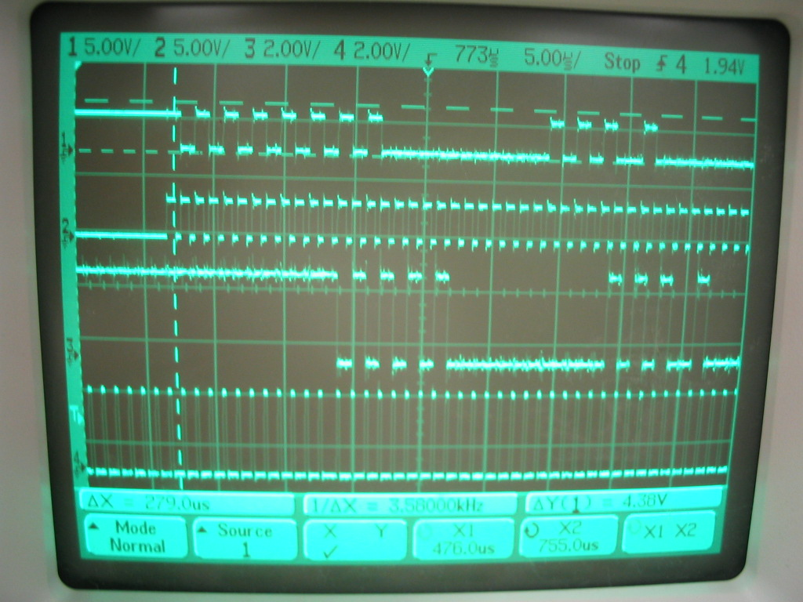
Figure 52 - Receiver Out of Synch

System Definition
The schematic pin to pin interface between the PIC and the FSK chip is shown below in . This shows the pins necessary for the input data and connection to the FSK chip.

Figure 53 - Transmit Side Pin to Pin PIC-FSK Connections
The receiver side schematic is shown in Figure 54. The Vref in on the DAC is tied to Vdd on the PIC so that it uses the same threshold voltage.
Figure 54 - Receiver Side Pin to Pin FSK -PIC-DAC Connections

Budget and Parts List
The parts list is shown below in . Several extra parts were purchased in case anything broke.
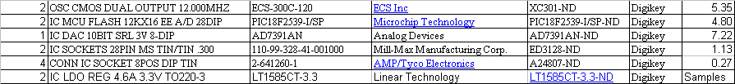
Table 22 - Preliminary Parts List

Final Design
The final hardware produced is shown below in Figure 55. The PIC microchip is on the green board. There are data control line wires that go to the FSK chip. Also shown is the power supply (batteries) and the voltage regulator. The additional chip on there is an AND gate so that the synchronous clock is not sent to the FSK chip when transmitting data.
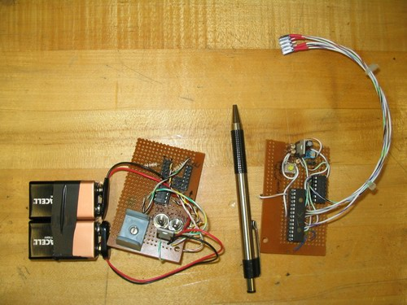
Figure 55 - TX Side PIC Hardware

Below in Figure 56 is the receiver side PIC microchip. It has a power supply and voltage regulator.
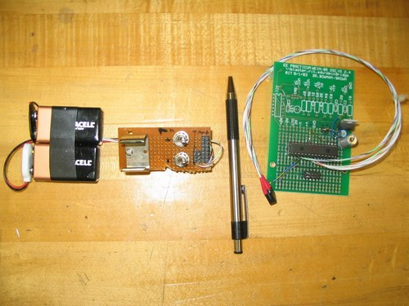
Figure 56 - RX Side PIC

Future Improvements
There are many possibilities with this project. Some options are to apply encoding on the digital data for possible error correction codes. Additional inputs could also be used on the PIC to transmit digital data. A wireless RS-232 system could easily be made by simply using the MSSP on the TX PIC as the source of data. As of now the system is only simplex transmission, thus it can only transmit one way. The FSK chip is a transceiver, thus the system could be turned into a more robust duplex system.

Project Results and Improvements

Senior Design II Time Line
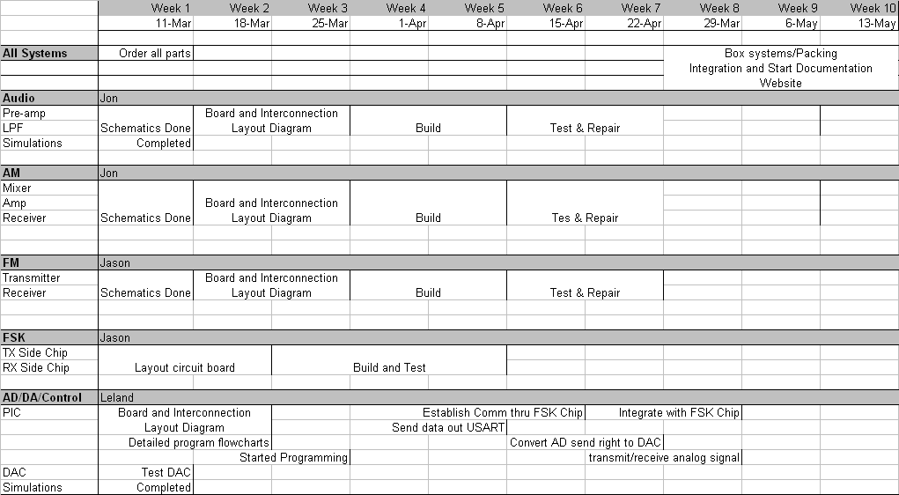

System Functionality
The results and performance of each subsystem were addressed in the proceeding sections; they are outlined here.

Functions | Percent Complete
Microphone Amplifier | 100
Audio Gain Blocks | 100
Audio Filter | 100
AM Transmitter | 75
AM Receiver | 75
FM Transmitter | 80
FM Receiver | 100
FSK Transmitter | 100
FSK Receiver | 100
Audio Quantizing | 100
FSK Transmitter Digital Control | 100
FSK Transmitter Data Stream | 100
FSK Receiver Digital Control | 100
FSK Receiver Address Recognition | 50
Table 23 – System Progress

Budget

Item | Price ($)
Board Layout | 100
FM Transmitter Parts | 40
FM Receiver Parts | 30
GFSK Transceiver Parts | 30
Audio Section parts | 25
AM Receiver Parts | 30
AM Transmitter Parts | 30
PIC Implementations | 15
Power Supply | 15
RF Cables | 30
Misc. Prototype Materials | 20
Estimated Total | 365
Actual Cost | 390
Additional parts | 110
Table 24 – Budget Analysis

The budget proposal is shown in Table 24. This proposal was original given with a $75 expected variance. As can be seen the actual cost is within that margin. Also shown is the $110 cost of additional parts. This shows the money spent on backup parts purchased in case a part was damaged of misplaced.

Future Improvements

Improve Quality of FM Transmitter
Currently, there is a large amount of distortion in the audio modulated from the FM transmitter. The cause of this distortion was unknown at the time of this report. The team would like to have the issue resolved before the project is turned over to the advisers. However, if the problem is not found, the diagnosis could be preformed by future design teams.

Code Refinement
As with most communication systems, the complexity of coding has almost limitless possibilities. An array of error detection and correction measures can be added. Data sampling and synchronization can also be upgraded. This can all me achieved through the development of software for the microcontroller. If necessary, the microcontroller could also be upgraded to a faster, more capable unit.

Student Projects, Labs, and Curriculums
The systems created during the course of this project have the potential to be developed into a variety of laboratories and student projects above and beyond their original intended use. Faculty, graduate students, or future design teams could explore the capabilities of the units and could create projects or libratory experiments to assign to students. For example, the FSK device could be used to teach students the implementations of digital communication techniques. Also, the FM Transmitter of receiver could be reproduced by students in the EE practicum course as communications related supplement to their course work.

Appendix A – References

“RS232 Specifications and standard”, Lammert Bies. (http://www.lammertbies.nl/comm/info/RS-232_specs.html)

“What is USB?”, bugclub.org. (http://bugclub.org/beginners/hardware/usb.html)

“Telecommunication - Operation within the bands 902-928 MHz, 2400-2483.5 MHz, and 5725-5850 MHz.” TITLE 47, CHAPTER I, PART 15, Subpart C, Sec. 15.247; FEDERAL COMMUNICATIONS COMMISSION (http://www.access.gpo.gov/nara/cfr/waisidx_03/47cfr15_03.html)

“United States Frequency Allocations ‘The Radio Spectrum’” October 2003, U.S. Department of Commerce, National Telecommunications and Information Administration, Office of spectrum Management (http://www.ntia.doc.gov/osmhome/allochrt.pdf)

“Unlicensed Frequencies“, zytrax.com (http://www.zytrax.com/tech/wireless/free.htm)

NRF2401 Data Sheet: “Single Chip 2.4 GHZ Transceiver”, Rev. 1.1, Nordic Semiconductor

NAN24-05 Application Note: “nRF24e1 Wireless Hand-Free Demo” , Rev. 1.2, Nordic Semiconductor

NAN24-04 Application Note: “Universal Low Cost USB DuoCeiver Using an nRF2401” , Rev. 1.0, Nordic Semiconductor

NAN400-07 Application Note: “nRF Radio Protocol Guidelines” , Rev. 1.2, Nordic Semiconductor

Design of Analog Filters, Rolf Schaumann and Mac E. Van Valkenburg, Oxford University Press.

Modulation, 2nd edition. F R Connor, Thomson Litho Limited.

Electronic Communications Modulation and Transmission, 2nd edition. Robert Schoenbeck, Macmillian Publishing Company.

Digital Communications Fundamentals and Applications, 2nd edition, Sklar

Appendix B – Design Documents

FM Transmitter Schematic
J. Riesbeck
3/14/2005

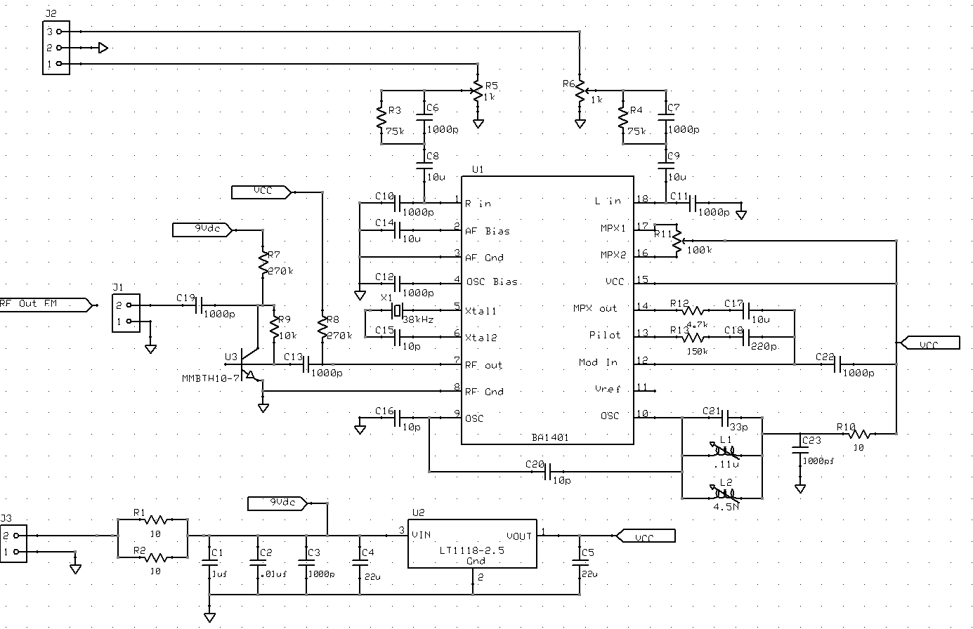

Parts List – FM Transmitter
J. Riesbeck
3/14/2005
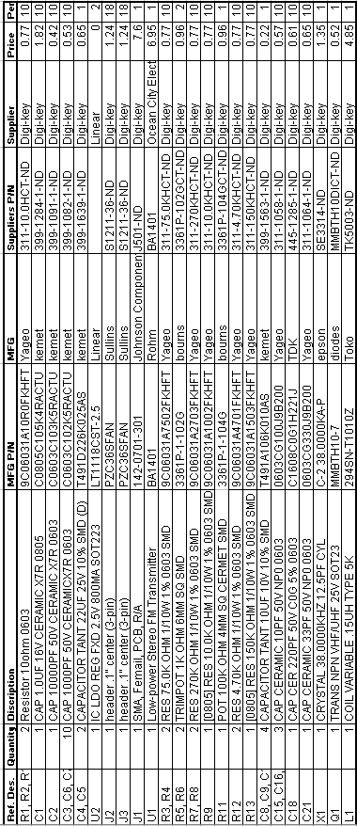

Interconnection Control Document - FM Transmitter Board
J. Riesbeck
2/5/2005

Scope: This document outlines the Input/Output connectors on the FM Transmitter Board. Pin-outs will be covered.

IO Connectors:
Connector | J1
Pin | Description | Signal type | Cable Type |  | Max Voltage/Current
1 | RF Out | RF | Coaxial |  | +1w
Type | SMA Female

Connector | J2
Pin | Description | Signal type | Cable Type |  | Max Voltage/Current
1 | Audio in R | Analog | Twisted pair |  | 700mV/
2 | Gnd | Analog | shield
3 | Audio in L | Analog | Twisted pair |  | 700mV/
Type | 1x3 .1” on center Header

Connector | J3
Pin | Description | Signal type | Cable Type |  | Max Voltage/Current
1 | Ground | Gnd | Single conductor |  | 0/30mA
2 | Supply Voltage | Pwr | Single conductor |  | 10V/30mA
Type | 1x2 .1” on center Header

Test Procedure – FM Transmitter
4/1/05
J. Riesbeck

Equipment:
Standard Function generator (for audio)
Standard FM Radio Receiver
Standard Oscilloscope (>60kHz)
Spectrum Analyzer (80-110MHz)

Related Documents:
FM Transmitter Schematic

Initial Test
- Check power and data pins for shorts to ground.
- Apply power (9V) to power pin.
- Check current draw. (~20mA)
- Check voltage at pin 1 of U2 (2.5V)

Operational Test
- Apply a 1kHz audio signal to the audio input
- Tune transmitter using L1
- Use spectrum Analyzer to check for signal output.
- Use receiver to tune to transmitter signal.
- Connect Oscilloscope to audio output and check for correctness

FM Receiver Schematic
J. Riesbeck
1/27/2005
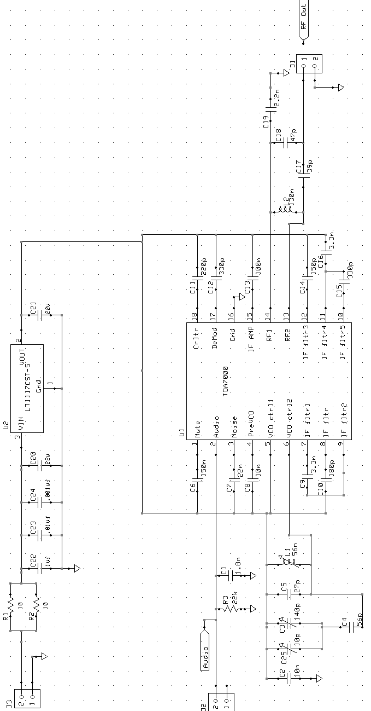

Parts List – FM Receiver
J. Riesbeck
2/1/2005
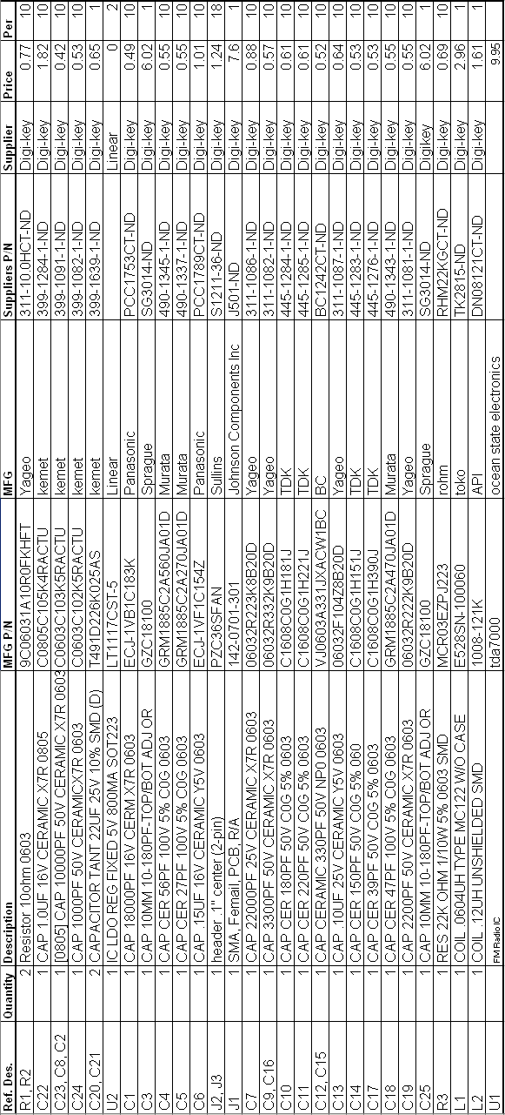

Interconnection Control Document - FM Receiver Board
J. Riesbeck
1/30/2005

Scope: This document outlines the Input/Output connectors on the FM Receiver Board. Pin-outs will be covered. This document will contain all the necessary information to communicate and control the FM Receiver Board.

IO Connectors:
Connector | J1
Pin | Description | Signal type | Cable Type |  | Max Voltage/Current
1 | RF In | RF | Coaxial |  | -
Type | SMA Female

Connector | J2
Pin | Description | Signal type | Cable Type |  | Max Voltage/Current
1 | Reserved
2 | Audio Out | Analog | Single conductor |  | 100mV/
Type | 1x2 .1” on center Header

Connector | J3
Pin | Description | Signal type | Cable Type |  | Max Voltage/Current
1 | Ground | Gnd | Single conductor |  | 0/30mA
2 | Supply Voltage | Pwr | Single conductor |  | 15V/30mA
Type | 1x2 .1” on center Header

Test Procedure – FM Receiver
4/1/05
J. Riesbeck

Equipment:
Standard FM Radio Receiver
Standard Oscilloscope (>60kHz)

Related Documents:
FM Receiver Schematic

Initial Test
- Check power and data pins for shorts to ground.
- Apply power (6-15V) to power pin.
- Check current draw. (~10mA)
- Check voltage at pin 2 of U2 (5V)

Operational Test
- Tune existing receiver to a strong broadcast station.
- Connect Oscilloscope to audio output.
- Use C3 to tune receiver in test to same station as above
- Connect Oscilloscope to audio output and compare with above

FSK Transceiver Schematic
J. Riesbeck
1/25/2005
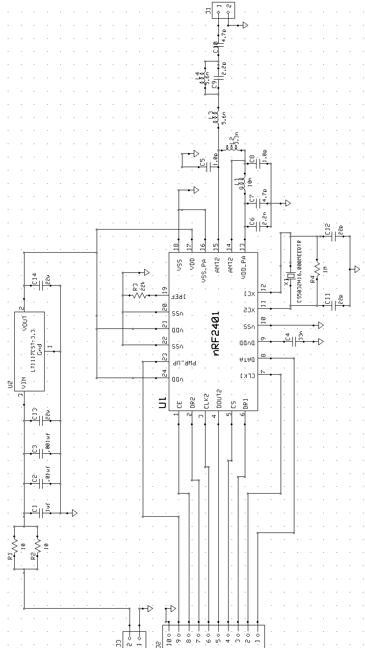
Parts List – FSK Transceiver
J. Riesbeck
2/1/2005
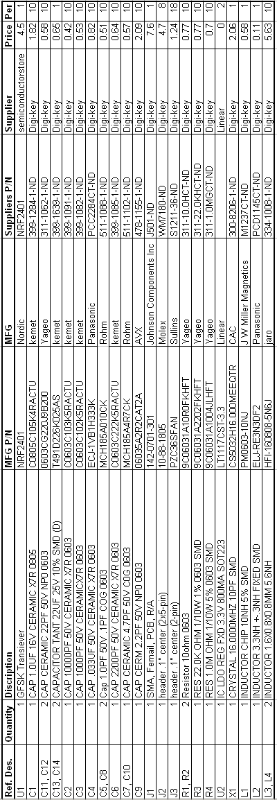

Interconnection Control Document - GFSK Board
J. Riesbeck
1/29/2005

Scope: This document outlines the Input/Output connectors on the GFSK board. Pin-outs will be covered as well as data timing and control word architecture. This document will contain all the necessary information to communicate and control the GFSK board.

IO Connectors:
Connector | J1
Pin | Description | Signal type | Cable Type |  | Max Voltage/Current
1 | RF Out/In | RF | Coaxial |  | 3dBm
Type | SMA Female

Connector | J2
Pin | Description | Signal type | Cable Type |  | Max Voltage/Current
1 | Data RX and TX | Digital | Single conductor |  | 3.6V/
2 | Clock for TX/RX | Digital | Single conductor |  | 3.6V/
3 | Data Ready (RX) | Digital | Single conductor |  | 3.6V/
4 | Chip Select | Digital | Single conductor |  | 3.6V/
5 | RX Data (Ch2) | Digital | Single conductor |  | 3.6V/
6 | Clock (Ch2) | Digital | Single conductor |  | 3.6V/
7 | Data Ready (Ch2) | Digital | Single conductor |  | 3.6V/
8 | Chip Enable | Digital | Single conductor |  | 3.6V/
9 | Power Up | Digital | Single conductor |  | 3.6V/
10 | Reserved
Type | 2x5 .1” on center Header

Connector | J3
Pin | Description | Signal type | Cable Type |  | Max Voltage/Current
1 | Ground | Gnd | Single conductor |  | 0/15mA
2 | Supply Voltage | Pwr | Single conductor |  | 15V/15mA
Type | 1x2 .1” on center Header

See GFSK Board Protocol Guidelines.

Test Procedure – GFSK Transceiver
4/1/05
J. Riesbeck

Equipment:
Two (2) GFSK Transceiver boards
Two (2) 2.4GHz Antennas
Two (2) SMA to SMA cables
Microcontroller able to send configuration word
Spectrum Analyzer (>2.4GHz)

Related Documents:
GSFK Board Protocol Guidelines

Initial Test
- Check power and data pins for shorts to ground.
- Apply power (4-15V) to power pin.
- Check current draw. (~10mA)
- Check voltage at pin 2 of U2 (3.3V)

Operational Test
- Send configuration word (See communications protocol document).
- Set one GSFK board for receive and one for transmitter
- TX_ Send arbitrary series of data bits (10101010)
- Using spectrum analyzer, check RF output for data at 2.3GHz
- RX_ Check for received data

GFSK Board Protocol Guidelines
J. Riesbeck
9/10/2005

Scope: This document describes the process of sending data to the FSK board for the purpose of configuration, transmitting, and reception. Data formatting and timing will be discussed.

Figure 1 – Function Control Pins

Pin | Description
PWR_UP | Power Up
CE | Chip Enable
CS | Chip Select
CLK1 | Data Clock (Channel 1)
DATA1 | Data (Channel 1)
DR1 | Data Ready (Channel 1)
*CLK2 | Data Clock (Channel 2)
*DATA2 | Data (Channel 2)
*DR2 | Data Ready (Channel 2)
Table 1 – Pin Summary
*Not used in this application, See NRF2401 datasheet for incorporation

Power Up:
To turn on the transceiver set the PWR_UP high (3.3V).

Power Down:
Ser PWR_UP low (0V). As long as power is supplied to the board, the control word will be maintained in power down mode. Current consumption is reduced to 1uA in this mode.

Main Operation Modes:
Mode | Chip Enable (CE) | Chip Select (CS)
Configuration | 0 | 1
Stand By | 0 | 0
Active (RX/TX) | 1 | 0
Table 2 – nRF2401 Chip Modes

Configuration:
Configuration settings are necessary for general chip operation and protocol setting. The protocol can be configured in one of two modes; SockBurstTM or Direct.

In direct mode the device operates like a typical RF transceiver where encoding and synchronization are handled by a connected microcontroller. This configuration will not be used for this application. See NRF2401 datasheet for configuration in this mode.

In SockBurstTM the receiver will handle all RF protocol and synchronization automatically. Both receiver and transmitter should be configured identically with the same address. Table 3 shows the proposed settings for this project and their proposed bit values.
Bits | Value | Binary | Description
D119:D118 | 100 | 01100100 | Payload Width (Channel 2)
D111:D104 | 100 | 01100100 | Payload Width (Channel 1)
D103:D63 | 85 | ...01010101 | Address (Channel 2)
D62:D24 | 85 | …01010101 | Address (Channel 1)
D23:D18 | 8 | 001000 | Address Width
D17 | 8-bits | 0 | CRC Code Length
D16 | Enable | 1 | CRC Enable
D15 | One | 0 | Number of Channels
D14 | ShockBurst | 1 | Communication Mode
D13 | 1Mbps | 1 | Data Rate (1M/250k)
D12:D10 | 16MHz | 011 | Crystal Frequency
D9:D8 | 0dB | 11 | RF Power
D7:D1 | 2408MHz | 0001000 | RF Channel
D0 | TX/RX | 0/1 | Transmit or Receiver Select
Table 3 – Control Word Values

Resulting Configuration Word in Hex:
646400000000550000000055216F11
X=0 for Transmit, 1 for Receive

Procedure for sending Configuration Word:
- Set “CS” pin high and wait at least 5us.
- Start Clocking data in at less than 1Mbps (data on “Data1” and clock on “Clock1”)
- Data is read on the raising edge of the clock.
- After the 120bit configuration word, set the “CS” pin low again.
ShockBurst:
The ShockBurst feature on this board will automatically CRC code, transmitter, receive, decode, and store the data packet.

Figure 2 – Packet Path

The transmitting micro controller must supply the board with a data packet (including address configured above).

Procedure for sending data packet:
- Set “CE” pin high and wait at least 5us.
- Start clocking the data packet data at less than 1Mbps (data on “Data1” pin and clock on “Clock1” pin)
- Data is read on the raising edge of the clock.
- After the entire data word is sent, set the “CE” pin low again.
Procedure for receiving data packet:
- Set “CE” pin high. This instructs the receiver to start listening for data.
- When a packet is received by the receiver, the data ready (DR) pin will go high.
- Start clocking out the data packet data at less than 1Mbps (data on “Data1” pin and clock on “Clock1” pin)
- Data is read on the raising edge of the clock.
- After the entire data word is sent, set the “CE” pin low again.

GFSK Control Word
J. Riesbeck
1/29/2005
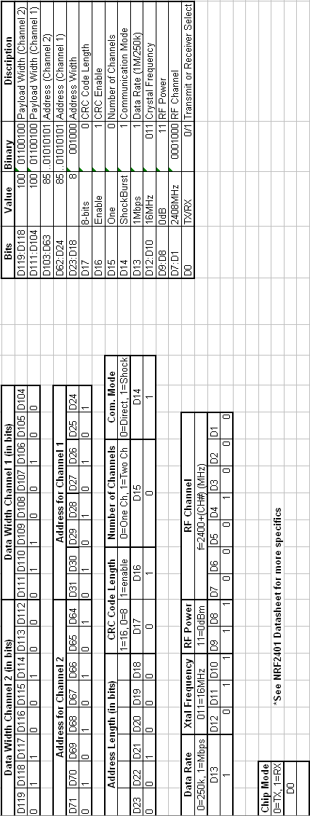

Further Look into ISM Band Regulations
J. Riesbeck
1/15/2005

Scope:
This document covers the power level limitations for an ISM band implementation.

As per FCC regulations document (refferance1B):

“ TITLE 47--TELECOMMUNICATION

CHAPTER I--FEDERAL COMMUNICATIONS COMMISSION

PART 15--RADIO FREQUENCY DEVICES--Table of Contents

Subpart C--Intentional Radiators

Sec. 15.247 Operation within the bands 902-928 MHz, 2400-2483.5 MHz, and 5725-5850 MHz.

(a) Operation under the provisions of this section is limited to
frequency hopping and digitally modulated intentional radiators that
comply with the following provisions:

…
(b) The maximum peak output power of the intentional radiator shall
not exceed the following:
…
(3) For systems using digital modulation in the 902-928 MHz, 2400-
2483.5 MHz, and 5725-5850 MHz bands: 1 Watt.
(4) Except as shown in paragraphs (b)(3) (i), (ii) and (iii) of this section, if transmitting antennas of directional gain greater than 6 dBi are used the peak output power from the intentional radiator shall be reduced below the stated values in paragraphs (b)(1) or (b)(2) of this section, as appropriate, by the amount in dB that the directional gain of the antenna exceeds 6 dBi.”

Conclusion:
Transmissions are limited to 1watt or +30dBm

Antenna Gain:
Per section 15.247.b.4 antenna gain can be as much as 6dB. After which, the transmit power must be reduced by 1dB for every 1dB increase in antenna gain.

Choosing Capacitors
What does NP0, C0G, and X7R mean and why does it matter?
J. Riesbeck
2/8/05

Scope: This document explores the dielectric characteristics available for capacitors and why they should be considered

The capacitance of all capacitors will change if their operating temperature deviates from room temperature. At first this may not appear to be a concern for implementations that are used strictly in temperature controlled areas. However, the fact remains that all electrical circuits consume power and there for produce heat. Therefore, the value of a capacitor may change as the circuit board/chassis warms to operating temperature. Also, all capacitors have associated with them an equivalent series resistance (ESR). This resistance dictates how much power the capacitor itself will consume, which in some cases is enough to result in a measurable heat and therefore change in capacitance.

Another major consideration is a capacitors tendency to change effective capacitance over a range of frequencies. This phenomenon is often much more drastic than the change due to temperature. Typically, the more a component changes with temperature, the more it with change with frequency.

Different types if dielectrics will be represented by a three character long alphanumeric series. Some of the more common coefficients are listed below.
X5R
X7R
Y5V
Z5U
COG (same as NP0)

These codes will tell you how much the capacitance will change over temperature. Table (1) contains the information necessary to decipher the temperature coefficients.

First Letter  Low Temperature Limit | Center Digit  High Temperature Limit | Last Letter  Max Capacitance Change
C = -55°C | 0 = +125°C | F = +/- 7.5%
X = -55°C | 5 = +84°C | G = +/- 30PPM/°C
Y = -30°C | 6 = +105°C | P = +/- 10%
Z = +10°C | 7 = +125°C | R = +/- 15%
 | 8 = +150°C | S = +/- 22%
 |  | T = +22% / -33%
 |  | U = +22% / -56%
 |  | V = +22% / -82%
Table 1 – Temperature Coefficient Decoding

C0G capacitors obviously have the best performance with a maximum capacitance change of only 0.03% over their temperature range.
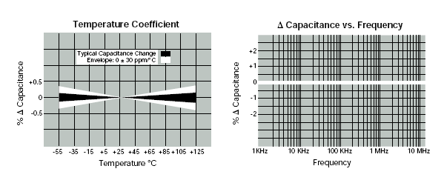Figure 1 – C0G (NP0) Capacitance Performance

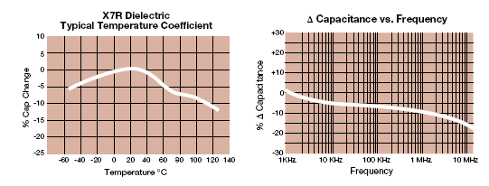
Figure 2 –X7R Capacitance Performance

Figures 1 and 2 shows the differences between a NP0 and X7R capacitor performance (from the datasheet for AVX brand size 0805 capacitors).

Conclusion:
It is quite obvious from figures 1 and 2 that the change in capacitance from some dielectrics can be drastic. Special attention is paid to the to frequency graph in figure 2. This graph indicates that a X7R capacitor would have a completely different effective capacitance if used in out 2.4GHz system. Furthermore, we do not have the recourses to perform a Monte Carlo analysis on our system because model information does not exist for the components we are using. Therefore it is hard to tell which components in our design need to be of a quality dielectric and which do not.

The best course of action would be to purchase NP0 type for all caps which are connected to RF paths. NP0 caps are roughly %25 more expensive then their cheaper counterparts meaning this decision has a minute affect on the cost of the project.
PIC Microchip TX Side – With Synchronization Word

;******************************************************************************
; *
; Filename: SDPv1.asm *
; Date: 3/25/05 *
; File Version: *
; *
; Author: Leland Smith *
; Company:+
; Modifications:
; 5/7/05: This program sends out the Synch two bytes right after
; each preamble-made a synch function
; -increased Toa break by 16us
; -Added 10101010 to each tx byte *
; *
;******************************************************************************
; *
; Files required: P18F2525.INC *
; 18F2525.LKR *
; *
; *
; *
;******************************************************************************

LIST P=18F2525, F=INHX32 ;directive to define processor
#include <P18F2525.INC> ;processor specific variable definitions

;******************************************************************************
;Configuration bits
; The __CONFIG directive defines configuration data within the .ASM file.
; The labels following the directive are defined in the P18F2525.INC file.
; The PIC18FX525/X620 Data Sheet explains the functions of the
; configuration bits.

__CONFIG _CONFIG1H, _OSC_INTIO67_1H & _FCMEN_ON_1H & _IESO_OFF_1H
__CONFIG _CONFIG2L, _PWRT_OFF_2L & _BOREN_OFF_2L & _BORV_25_2L
__CONFIG _CONFIG2H, _WDT_OFF_2H & _WDTPS_1_2H
__CONFIG _CONFIG3H, _MCLRE_OFF_3H & _PBADEN_OFF_3H & _CCP2MX_PORTBE_3H
__CONFIG _CONFIG4L, _DEBUG_OFF_4L & _LVP_OFF_4L & _STVREN_OFF_4L & _ENHCPU_OFF_4L
__CONFIG _CONFIG5L, _CP0_OFF_5L & _CP1_OFF_5L & _CP2_OFF_5L
__CONFIG _CONFIG5H, _CPB_OFF_5H
__CONFIG _CONFIG6L, _WRT0_OFF_6L & _WRT1_OFF_6L & _WRT2_OFF_6L
__CONFIG _CONFIG6H, _WRTB_OFF_6H & _WRTC_OFF_6H
__CONFIG _CONFIG7L, _EBTR0_OFF_7L & _EBTR1_OFF_7L & _EBTR2_OFF_7L
__CONFIG _CONFIG7H, _EBTRB_OFF_7H & _DEVID1 & _IDLOC0

;******************************************************************************
;Variable definitions
; These variables are only needed if low priority interrupts are used.
; More variables may be needed to store other special function registers used
; in the interrupt routines.

;Set pause times for Timer0
;Timer0 is set as 16us/count and 16 bit counter
;If you need more than 255 counts, you must use high byte!
;Timer counts up and sets TMIF from FF-00.
;So: FFFF-(counts desired)=TMR0 value

;Time on air (Direct Mode)
ToaDM EQU 0x0B ;TMR0L byte: FFFF-(counts in hex)=FF
Tsby2txDM EQU 0xF1 ;TMR0L byte for 192us count
FrameSize EQU 0xD2 ;max = 250 = 4.0ms
Synch1 EQU b'11010110' ;first synch byte
Synch2 EQU b'00001111' ;second synch byte
SynchFrame EQU 0x01 ;1 synch words before each frame

UDATA

WREG_TEMP RES 1 ;variable in RAM for context saving
STATUS_TEMP RES 1 ;variable in RAM for context saving
BSR_TEMP RES 1 ;variable in RAM for context saving
ADH RES 1 ;high byte of AD conv
ADL RES 1 ;low byte of AD conv
ADH2 RES 1
ADL2 RES 1
COUNT RES 1 ;counts up each 2 bytes send, each tx loop
WAIT RES 1 ;temp reg to store wait time for wait function
SynchTime RES 1 ;counting reg for how many synch frames are sent

UDATA_ACS

;******************************************************************************
;Reset vector
; This code will start executing when a reset occurs.

RESET_VECTOR CODE 0x0000

goto Main ;go to start of main code

;******************************************************************************
;High priority interrupt vector
; This code will start executing when a high priority interrupt occurs or
; when any interrupt occurs if interrupt priorities are not enabled.

HI_INT_VECTOR CODE 0x0008

bra $ ;go nowhere

;******************************************************************************
;Low priority interrupt vector and routine
; This code will start executing when a low priority interrupt occurs.
; This code can be removed if low priority interrupts are not used.

LOW_INT_VECTOR CODE 0x0018

bra LowInt ;go to low priority interrupt routine

CODE
;******************************************************************************
;This function will wait WAIT for under 255 counts = 4.08ms
;using Timer0. This is not suitable for use with interupts since
;this function remains in loop until timer is done.
WaitTimer0:
bsf T0CON,TMR0ON ;Start timer
Timer0Loop:
btfss INTCON,TMR0IF ;if TMR0IF high move on
bra Timer0Loop ;wait if TMR0IF flag is not high
bcf T0CON,TMR0ON ;turn off timer0
bcf INTCON,TMR0IF ;clr timer0 interupt flag
return
;end wait
;Waits for TXREG in USART to clear
WaitTXREG:
btfss PIR1,TXIF ;<PIR:4>if TXREG is clear (TXIF=0), skip next line
bra WaitTXREG ;TXREG not clear

return
;end USART
;Waits for TSR to clear, TRMT bit goes high
WaitTSR
btfss TXSTA,TRMT ;Wait for
bra WaitTSR ;TSR not clear

return
;end
;Wait for AD conversion to complete
WaitAD:
btfsc ADCON0,GO ;If AD sample is complete (GO clear) continue
bra WaitAD ;If AD not complete (GO high), wait

return
;**********************
;Synch routine; Send out synch frame
;
SendSynch:
movlw SynchFrame ;how many frames to send
movwf SynchTime ;put in variable
;Send Preamble
; movlw b'01010101' ;preamble already sent in break
; movwf TXREG ;takes 1tcy
; call WaitTXREG
; movwf TXREG ;send another
; call WaitTXREG
;no preamble again...
SynchLoop:
movlw Synch1
movwf TXREG
call WaitTXREG
movlw Synch2
movwf TXREG
call WaitTXREG ;wait to load next byte
;check if counter is done
decfsz SynchTime ;reduce counter and skip BRA if =0
bra SynchLoop
call WaitTXREG ;
;now SynchFrame # of 16-bit words were sent
return

;End SendSynch

;Start of main program

Main:

;Set internal clock to 8MHz
movf OSCCON, W ;move data to accumulator to be modified
iorlw b'01110000' ;set 8MHz operation
movwf OSCCON
movlw 0x40; b'01000000'
movwf OSCTUNE ;set to use PLL (Fosc*4)

;Set up interrupts.
clrf INTCON
clrf INTCON2
clrf IPR1 ;set AD, UART RX & TX to low priority int's
bsf RCON,IPEN ;enable priority interrupts.
bcf INTCON2,TMR0IP ;set Timer0 as a low priority interrupt source
bcf INTCON,TMR0IF ;clear the Timer0 overflow flag
bsf INTCON,GIEH ;enables high priority interrupts
bsf INTCON,GIEL ;enables low priority interrupts
; bsf PIE1,TMR1IE ;enable timer1 overflow interupt
; bsf PIE1,ADIE ;enables AD converter interupt (don't want)
; bsf PIE1,RCIE ;enables USART receive interupt
; bsf PIE1,TXIE ;enables USART transmit interupt (don't want)

;Power up routine FSK chip
;Initialize PortB for FSK chip programming
clrf LATB ;
clrf TRISB ;make PORTB all outputs
bsf PORTB,RB0 ;pwr up (need to wait 3ms to send data)
bsf PORTB,RB2 ;chip select (need to wait 5us until send word)

;Set generic timer
;Timer0 setup
clrf T0CON ;Clear timer reg
bcf T0CON,b'110' ;Set timer as 16-bit (bit 6)
bsf T0CON,T0PS1 ;Set to prescale by 1:8 (bit 2:0 = 010)
bsf T0CON,T0PS2 ;Set prescale to 1:128=16us per count

;Timer0 Startup time 100ms
;need to count 188 counts*16us/count=3ms
;FFFF-187A=E795h
movlw 0xE7
movwf TMR0H
movlw 0x95 ;Set timer counter initial value
movwf TMR0L ;Set Desired Low Byte in Timer
call WaitTimer0 ;Now branch to Timer0 wait routine

;USART Setup
clrf SPBRGH
movlw 0x07 ;set n=7 in SPBRG for 1MHz UART TX Synch
movwf SPBRG
bsf RCSTA,SPEN ;serial port enabled
bcf TXSTA,TX9 ;8-bit transmission
;bsf TXSTA,BRGH ;high speed transmission (affects Synch only)
bcf BAUDCON,BRG16 ;use 8-bit BRG
;set TRISC <7:6> as 1
movlw b'11000000'
movwf TRISC
;Synchronous Setup
bsf TXSTA,CSRC ;Synch Master Mode use int clock
bsf TXSTA,SYNC ;set UART for synchronous transmission

bsf TXSTA,TXEN ;turn on UART
;******************************
;Send configuration word to FSK

movlw b'11110100' ;config word MSB in config word=LSB here
movwf TXREG
call WaitTXREG ;wait for TXREG to clear
movlw b'00000001'
movwf TXREG
call WaitTSR ;wait for TSR to clear
;Turn off CS line cause config data was sent by now
bcf PORTB,RB2

;A/D Setup
movlw b'00000001'
movwf TRISA ;set AN0 as an input
clrf PORTA ;
movlw b'00001101' ;set Vref-=Vss, Vref+=Vdd
movwf ADCON1 ;AN12-AN2 digital, AN1-AN0 analog input
clrf ADCON0 ;use channel 0, AD converter disabled
movlw b'10010010' ;Right justified AD result, 2TAD acqt
movwf ADCON2 ;64 TAD acq time and Fosc/32=1us conversion time
bsf ADCON0,ADON ;Turn on AD module
;******************************************
;Enable CE line to start sending synch data
bsf PORTB,RB1

;Wait Tsby2txDM 202us after CE line
;need to count 12 counts=192us
;FFFF-D=FFF9h
movlw 0xFF
movwf TMR0H
movlw Tsby2txDM ;Set timer counter initial value
movwf TMR0L ;Set Desired Low Byte in Timer
call WaitTimer0 ;now wait

;;Set interupt to wait <ToaDM (3ms < 4ms) after CE line
; ;need to count 188 counts=3ms (16us=1 count)
; ;FFFF-BC=FF43h
; ;244 counts=3.904ms: FF0B
; movlw 0xFF
; movwf TMR0H
; movlw ToaDM ;Set timer counter initial value
; movwf TMR0L ;Set Desired Low Byte in Timer
; bsf T0CON,TMR0ON ;Start timer

;Start AD
bsf ADCON0,GO ;Start conversion (14 TAD=14us)
;wait for AD to complete
call WaitAD

movff ADRESH,ADH ;store away AD
movff ADRESL,ADL

bsf ADCON0,GO ;start another AD
call WaitAD
movf ADRESL,W ;swap new AD with old one
movff ADL,ADRESL
movwf ADL
movf ADRESH,W
movff ADH,ADRESH
movwf ADH
;***********************************
; Start Data Transmission
;***********************************
;Send Preamble
movlw b'01010101'
movwf TXREG ;takes 1tcy
call WaitTXREG
;send another preamble for laughs
;the first bit of the second byte must be the same as 1st in preamble
movwf TXREG ;takes 1tcy
call WaitTXREG

call SendSynch ;send out synch frame
;At this point we are under the 8us where the first two words havn't been
;transmitted. From now on we have to send one word every 8us.

;Send out old conversion before loop
movlw b'10101010' ;add bits to other 6 digits. OR with: b'10101000'
addwf ADRESL ;changed from IOR
movff ADRESL,TXREG ;send old bit out first
addwf ADRESH ;changed from IOR
call WaitTXREG ;wait 8us
movff ADRESH,TXREG ;send old high byte out
;Grab another sample before loop and before waiting
bsf ADCON0,GO
movlw FrameSize
movwf COUNT ;Setup loop counter to TX one frame

call WaitTXREG
;*****************
;Enter repeat loop
UARTSendLoop:
movlw b'10101010' ;add bits to other 6 digits. OR with: b'10101000'
addwf ADL ;changed this to an ADD, from IOR
movff ADL,TXREG ;(TXREG empties after 1 Tcy)
addwf ADH
call WaitTXREG
;inbetween next 8us
movff ADH,TXREG ;8us to get next sample ready!

;Finished previous sample to store?
call WaitAD
;Done, so store into temp registers
movff ADRESL,ADL
movff ADRESH,ADH

bsf ADCON0,GO ;Get another sample

;check if counter is done
dcfsnz COUNT ;reduce counter and skip BRA if !=0
bra ToaBreak ;if Count=0 go to break
;counter

call WaitTXREG ;make sure high byte was sent!

bra UARTSendLoop

;end repeat TX loop
;******************
;Time on Air Break

ToaBreak

call WaitTSR ;Wait for TSR to clear
;set CE line low 1us after data is stopped sending out USART
bcf PORTB,RB1 ;clear CE line and wait 50ns
movlw FrameSize
movwf COUNT ;reset frame counter
movlw 0xFF
movwf TMR0H
bsf PORTB,RB1 ;Set CE line back high and wait
;Wait
movlw Tsby2txDM ;Set timer counter initial value
movwf TMR0L ;Set Desired Low Byte in Timer
call WaitTimer0 ;now wait 202us
;Done Wait
bsf ADCON0,GO
call WaitAD
;Done, so store into temp registers
movff ADRESL,ADL
movff ADRESH,ADH
;Send Preamble
movlw b'01010101'
movwf TXREG ;takes 1tcy
call WaitTXREG
movwf TXREG ;takes 1tcy
bsf ADCON0,GO
call WaitTXREG

call SendSynch ;now send synch frame

bra UARTSendLoop ;go back to send loop

;******************************************************************************
;Low priority interrupt routine
; The low priority interrupt code is placed here.
; This code can be removed if low priority interrupts are not used.

LowInt:

retfie ;end interupt

;******************************************************************************
;End of program

PIC18F2525 RX Side – With Synch Word Reception

;******************************************************************************
; *
; Filename: SDPv1RX2.asm *
; Date: 3/25/05 *
; File Version: *
; *
; Author: Leland Smith *
; Company: *
; *
;******************************************************************************
; *
; Files required: P18F2525.INC *
; 18F2525.LKR *
; 4/28/05: Added wait time for the 202us break, exactly as many counts
; as the TX side. Might need to wait longer. *
; *
; *
;******************************************************************************

LIST P=18F2525, F=INHX32 ;directive to define processor
#include <P18F2525.INC> ;processor specific variable definitions

;******************************************************************************
;Configuration bits
; The __CONFIG directive defines configuration data within the .ASM file.
; The labels following the directive are defined in the P18F2525.INC file.
; The PIC18FX525/X620 Data Sheet explains the functions of the
; configuration bits.

__CONFIG _CONFIG1H, _OSC_INTIO67_1H & _FCMEN_ON_1H & _IESO_OFF_1H
__CONFIG _CONFIG2L, _PWRT_OFF_2L & _BOREN_OFF_2L & _BORV_25_2L
__CONFIG _CONFIG2H, _WDT_OFF_2H & _WDTPS_1_2H
__CONFIG _CONFIG3H, _MCLRE_OFF_3H & _PBADEN_OFF_3H & _CCP2MX_PORTBE_3H
__CONFIG _CONFIG4L, _DEBUG_OFF_4L & _LVP_OFF_4L & _STVREN_OFF_4L & _ENHCPU_OFF_4L
__CONFIG _CONFIG5L, _CP0_OFF_5L & _CP1_OFF_5L & _CP2_OFF_5L
__CONFIG _CONFIG5H, _CPB_OFF_5H
__CONFIG _CONFIG6L, _WRT0_OFF_6L & _WRT1_OFF_6L & _WRT2_OFF_6L
__CONFIG _CONFIG6H, _WRTB_OFF_6H & _WRTC_OFF_6H
__CONFIG _CONFIG7L, _EBTR0_OFF_7L & _EBTR1_OFF_7L & _EBTR2_OFF_7L
__CONFIG _CONFIG7H, _EBTRB_OFF_7H & _DEVID1 & _IDLOC0

;******************************************************************************
;Variable definitions
; These variables are only needed if low priority interrupts are used.
; More variables may be needed to store other special function registers used
; in the interrupt routines.

ToaDM EQU 0x0B ;TMR0L byte: FFFF-(counts in hex)=FF
Tsby2txDM EQU 0xF0 ;TMR0L byte for 192us count
FrameSize EQU 0xD2 ;max = 250 = 4.0ms
Synch1 EQU b'11010110' ;first synch byte
Synch2 EQU b'00001111' ;second synch byte

UDATA

WREG_TEMP RES 1 ;variable in RAM for context saving
STATUS_TEMP RES 1 ;variable in RAM for context saving
BSR_TEMP RES 1 ;variable in RAM for context saving
RX_DataL RES 1 ;low byte of received sample
RX_DataH RES 1 ;high byte of received sample
COUNT RES 1 ;counts up each 2 bytes send, each tx loop
SReg RES 1 ;byte 1 for shift reg

UDATA_ACS

;******************************************************************************
;Reset vector
; This code will start executing when a reset occurs.

RESET_VECTOR CODE 0x0000

goto Main ;go to start of main code

;******************************************************************************
;High priority interrupt vector
; This code will start executing when a high priority interrupt occurs or
; when any interrupt occurs if interrupt priorities are not enabled.

HI_INT_VECTOR CODE 0x0008

bra $ ;go nowhere

;******************************************************************************
;Low priority interrupt vector and routine
; This code will start executing when a low priority interrupt occurs.
; This code can be removed if low priority interrupts are not used.

LOW_INT_VECTOR CODE 0x0018

bra LowInt ;go to low priority interrupt routine

CODE
;******************************************************************************
;This function will wait WAIT for under 255 counts = 4.08ms
;using Timer0. This is not suitable for use with interupts since
;this function remains in loop until timer is done.
WaitTimer0:
bsf T0CON,TMR0ON ;Start timer
Timer0Loop:
btfss INTCON,TMR0IF ;if TMR0IF high move on
bra Timer0Loop ;wait if TMR0IF flag is not high
bcf T0CON,TMR0ON ;turn off timer0
bcf INTCON,TMR0IF ;clr timer0 interupt
return
;end wait
;Waits for TXREG in USART to clear
WaitTXREG:
btfss PIR1,TXIF ;<PIR:4>if TXREG is clear (TXIF=0), skip next line
bra WaitTXREG ;TXREG not clear

return
;end USART
;Waits for TSR to clear, TRMT bit goes high
WaitTSR
btfss TXSTA,TRMT ;Wait for
bra WaitTSR ;TSR not clear

return
;end
;Waits for TSR to clear, TRMT bit goes high
WaitRCIF
btfss PIR1,RCIF ;Wait for RCIF to go high - reception occured
bra WaitRCIF ;TSR not clear
btfsc RCSTA,OERR ;did overrun error occur?
bcf RCSTA,CREN ;turn off continuous receive
bsf RCSTA,CREN ;turn it back on
;interupt flag cleared when RCREG is read
return
;end
;Wait for AD conversion to complete
WaitAD:
btfsc ADCON0,GO ;If AD sample is complete (GO clear) continue
bra WaitAD ;If AD not complete (GO high), wait

return
WaitSSPBUF
btfss PIR1,SSPIF ;is transmission complete?
bra WaitSSPBUF
bcf PIR1,SSPIF ;must be cleared in software!

return
;This routine is made for waiting for an interupt, it wil loop forever
JustWait
nop
nop
bra JustWait

return
;Start of main program

Main:

;Set internal clock to 8MHz
movf OSCCON, W ;move data to accumulator to be modified
iorlw b'01110000' ;set 8MHz operation
movwf OSCCON
movlw 0x40; b'01000000'
movwf OSCTUNE ;set to use PLL (Fosc*4)

;Set up interrupts.
clrf INTCON
clrf INTCON2
clrf IPR1 ;set AD, UART RX & TX to low priority int's
bsf RCON,IPEN ;enable priority interrupts.
bcf INTCON2,TMR0IP ;set Timer0 as a low priority interrupt source
bcf INTCON2,RBIP ;set Port B change as a low priority interrupt
bcf INTCON,TMR0IF ;clear the Timer0 overflow flag
bsf INTCON,GIEH ;enables high priority interrupts
bsf INTCON,GIEL ;enables low priority interrupts
bsf PIE1,TMR1IE ;enable timer1 overflow interupt
;RBPU is set for individual port pull u
bsf INTCON2,INTEDG0 ;RB0 interupt on rising edge

;Set generic timer
;Timer0 setup
clrf T0CON ;Clear timer reg
bcf T0CON,b'110' ;Set timer as 16-bit (bit 6)
bsf T0CON,T0PS1 ;Set to prescale by 1:8 (bit 2:0 = 010)
bsf T0CON,T0PS2 ;Set prescale to 1:128=16us per count

;Power up routine FSK chip
;Initialize PortB for FSK chip programming
clrf PORTB
clrf PORTC
clrf PORTA
clrf LATB ;
movlw b'00000001' ;set RB0 as input for CLK detect
movwf TRISB ;make other PORTB all outputs
movwf LATB
;***Power UP FSK***
bsf PORTB,RB3 ;pwr up (need to wait 3ms to send data)
bsf PORTB,RB2 ;chip select (need to wait 5us until send word)
;set TRISC <7:6> input for USART, rest output
movlw b'11000000'
movwf TRISC

;Keep /CLR and /LD line low on **DAC**
bcf PORTC,RC1
bcf PORTC,RC2

;Timer0 Startup time 100ms
;need to count x counts*16us/count=3ms
;FFFF-187A=E795h
movlw 0xE7
movwf TMR0H
movlw 0x95 ;Set timer counter initial value
movwf TMR0L ;Set Desired Low Byte in Timer
call WaitTimer0 ;Now branch to Timer0 wait routine

;MSSP Setup
clrf SSPCON1
bsf SSPCON1,SSPEN ;enable serial port
bsf SSPCON1,CKP ;clock idle state high
;bits 3-0 are 0 for Fosc/4 clock
bcf SSPSTAT,CKE ;transmit occurs from active to idle clock

;USART Setup
clrf SPBRGH
movlw 0x07 ;set n=7 in SPBRG for 1MHz UART Synch
movwf SPBRG
bsf RCSTA,SPEN ;serial port enabled
bcf TXSTA,TX9 ;8-bit transmission
bcf BAUDCON,BRG16 ;use 8-bit BRG

;USART Synchronous Setup
bsf TXSTA,CSRC ;Synch Master Mode use int clock
bsf TXSTA,SYNC ;set UART for synchronous transmission

bsf TXSTA,TXEN ;turn on UART
;***********
;Load TXREG with configuration word

movlw b'11110100' ;config word MSB in config word=LSB here
movwf TXREG
call WaitTXREG
movlw b'10000001'
movwf TXREG
call WaitTSR ;wait for total transmission to complete

;Turn off CS line cause config data was sent by now
bcf PORTB,RB2
;***********
;Make UART an input Synchronous Slave Mode
bcf TXSTA,CSRC ;put UART in slave mode (clock from ext)
bcf RCSTA,SREN ;don't care
bsf RCSTA,CREN ;enable continuous receive

;setup counter
movlw FrameSize
movwf COUNT ;Setup loop counter to TX one frame
;Enable CE line to start receiving synch data
bsf PORTB,RB1
;Clear DAC
bsf PORTC,RC1
nop
bcf PORTC,RC1

;****************************************************************
;Wait for Synch word
;enable interupt on portb 7:4
;
clrf SReg ;clear shift register
movlw Synch1 ;move first synch byte in W for cmp
bsf INTCON,RBIE ;enables RB Port Change int enable
call JustWait ;wait for interupt
Synch1Found: ;need to look for synch byte 2
cpfseq Synch1 ;does W reg contain 1st byte?
bra Synch2Found ;W has 2nd byte, skip to next
movlw Synch2 ;move second byte in W for cmp
clrf SReg ;clear shift register
call JustWait ;wait again for interupt
Synch2Found:
bcf INTCON,RBIE ;turn off RB port interupt enable
; clrf TRISB ;make portB all outputs again (don't want this)
bsf PORTB,RB7
;end Synch word
;**************
;Now receive regular data
UARTReceiveLoop:
; call WaitRCIF ;trash 2 preamble bytes
; call WaitRCIF ;
RXMainLoop:
call WaitRCIF ;wait for received word
movff RCREG,RX_DataL
call WaitRCIF
movff RCREG,RX_DataH ;don't need to mask out upper bits
; call WaitSSPBUF
;set /LD line low
bcf PORTC,RC2

movff RX_DataL,SSPBUF ;once written, it goes at 8MHz
; movlw b'11001100'
; movwf SSPBUF
call WaitSSPBUF ;gone in 1us
movff RX_DataH,SSPBUF ;send high byte
; movlw b'01010101'
; movwf SSPBUF
call WaitSSPBUF
;set /LD line high to let DAC process
bsf PORTC,RC2
;8us to until next word is read
;check if counter is done
dcfsnz COUNT ;reduce counter and skip BRA if !=0
bra ToaBreak ;if Count=0 go to break

bra RXMainLoop

;******************
;Time on Air Break

ToaBreak

call WaitSSPBUF ;Wait for MSSP to clear
;turn off USART to break synch
bcf TXSTA,TXEN ;turn off UART
;set CE line low 1us after data is stopped sending out USART
bcf PORTB,RB1 ;clear CE line and wait 50ns
movlw FrameSize
movwf COUNT ;reset count
movlw 0xFF
movwf TMR0H
bsf PORTB,RB1 ;Set CE line back high and wait
;Wait
movlw Tsby2txDM ;Set timer counter initial value
movwf TMR0L ;Set Desired Low Byte in Timer
call WaitTimer0 ;now wait 202us
btg PORTC,RC0
;turn back on UART, should be exactly where I need to be?
bsf TXSTA,TXEN ;turn on UART
call WaitRCIF ;trash 2 preamble bytes ??
call WaitRCIF ;???NO

bra UARTReceiveLoop ;go back to receive loop
;******************************************************************************
;Low priority interrupt routine

LowInt:

;low interupt means RB0 went high
; bcf INTCON,INT0IF ;clear interupt flag bit for RB0 (read RB0 clears it)
FirstByte:
btg PORTB,RB7 ;see its working
btfsc PORTB,RB5 ;sample port for data
incf SReg ;if data is 1, add one to lsb
rlncf SReg ;rotate data left, no carry
cpfseq SReg ;if it is equal byte1 skip next command
call JustWait ;its not equal, keep waiting
bra Synch1Found

retfie ;end interupt

;******************************************************************************
;End of program

END
PIC18F2525 Code RX Side – No Synch Word

;******************************************************************************
; *
; Filename: SDPv1RX2.asm *
; Date: 3/25/05 *
; File Version: *
; *
; Author: Leland Smith *
; Company: *
; *
;******************************************************************************
; *
; Files required: P18F2525.INC *
; 18F2525.LKR *
; 4/28/05: Added wait time for the 202us break, exactly as many counts
; as the TX side. Might need to wait longer. *
; *
; *
;******************************************************************************

LIST P=18F2525, F=INHX32 ;directive to define processor
#include <P18F2525.INC> ;processor specific variable definitions

;******************************************************************************
;Configuration bits
; The __CONFIG directive defines configuration data within the .ASM file.
; The labels following the directive are defined in the P18F2525.INC file.
; The PIC18FX525/X620 Data Sheet explains the functions of the
; configuration bits.

__CONFIG _CONFIG1H, _OSC_INTIO67_1H & _FCMEN_ON_1H & _IESO_OFF_1H
__CONFIG _CONFIG2L, _PWRT_OFF_2L & _BOREN_OFF_2L & _BORV_25_2L
__CONFIG _CONFIG2H, _WDT_OFF_2H & _WDTPS_1_2H
__CONFIG _CONFIG3H, _MCLRE_OFF_3H & _PBADEN_OFF_3H & _CCP2MX_PORTBE_3H
__CONFIG _CONFIG4L, _DEBUG_OFF_4L & _LVP_OFF_4L & _STVREN_OFF_4L & _ENHCPU_OFF_4L
__CONFIG _CONFIG5L, _CP0_OFF_5L & _CP1_OFF_5L & _CP2_OFF_5L
__CONFIG _CONFIG5H, _CPB_OFF_5H
__CONFIG _CONFIG6L, _WRT0_OFF_6L & _WRT1_OFF_6L & _WRT2_OFF_6L
__CONFIG _CONFIG6H, _WRTB_OFF_6H & _WRTC_OFF_6H
__CONFIG _CONFIG7L, _EBTR0_OFF_7L & _EBTR1_OFF_7L & _EBTR2_OFF_7L
__CONFIG _CONFIG7H, _EBTRB_OFF_7H & _DEVID1 & _IDLOC0

;******************************************************************************
;Variable definitions
; These variables are only needed if low priority interrupts are used.
; More variables may be needed to store other special function registers used
; in the interrupt routines.

ToaDM EQU 0x0B ;TMR0L byte: FFFF-(counts in hex)=FF
Tsby2txDM EQU 0xF0 ;TMR0L byte for 192us count
FrameSize EQU 0xD2 ;max = 250 = 4.0ms
Synch1 EQU b'11010110' ;first synch byte
Synch2 EQU b'00001111' ;second synch byte

UDATA

WREG_TEMP RES 1 ;variable in RAM for context saving
STATUS_TEMP RES 1 ;variable in RAM for context saving
BSR_TEMP RES 1 ;variable in RAM for context saving
RX_DataL RES 1 ;low byte of received sample
RX_DataH RES 1 ;high byte of received sample
COUNT RES 1 ;counts up each 2 bytes send, each tx loop
SReg RES 1 ;byte 1 for shift reg

UDATA_ACS

;******************************************************************************
;Reset vector
; This code will start executing when a reset occurs.

RESET_VECTOR CODE 0x0000

goto Main ;go to start of main code

;******************************************************************************
;High priority interrupt vector
; This code will start executing when a high priority interrupt occurs or
; when any interrupt occurs if interrupt priorities are not enabled.

HI_INT_VECTOR CODE 0x0008

bra $ ;go nowhere

;******************************************************************************
;Low priority interrupt vector and routine
; This code will start executing when a low priority interrupt occurs.
; This code can be removed if low priority interrupts are not used.

LOW_INT_VECTOR CODE 0x0018

bra LowInt ;go to low priority interrupt routine

CODE
;******************************************************************************
;This function will wait WAIT for under 255 counts = 4.08ms
;using Timer0. This is not suitable for use with interupts since
;this function remains in loop until timer is done.
WaitTimer0:
bsf T0CON,TMR0ON ;Start timer
Timer0Loop:
btfss INTCON,TMR0IF ;if TMR0IF high move on
bra Timer0Loop ;wait if TMR0IF flag is not high
bcf T0CON,TMR0ON ;turn off timer0
bcf INTCON,TMR0IF ;clr timer0 interupt
return
;end wait
;Waits for TXREG in USART to clear
WaitTXREG:
btfss PIR1,TXIF ;<PIR:4>if TXREG is clear (TXIF=0), skip next line
bra WaitTXREG ;TXREG not clear

return
;end USART
;Waits for TSR to clear, TRMT bit goes high
WaitTSR
btfss TXSTA,TRMT ;Wait for
bra WaitTSR ;TSR not clear

return
;end
;Waits for TSR to clear, TRMT bit goes high
WaitRCIF
btfss PIR1,RCIF ;Wait for RCIF to go high - reception occured
bra WaitRCIF ;TSR not clear
btfsc RCSTA,OERR ;did overrun error occur?
bcf RCSTA,CREN ;turn off continuous receive
bsf RCSTA,CREN ;turn it back on
;interupt flag cleared when RCREG is read
return
;end
;Wait for AD conversion to complete
WaitAD:
btfsc ADCON0,GO ;If AD sample is complete (GO clear) continue
bra WaitAD ;If AD not complete (GO high), wait

return
WaitSSPBUF
btfss PIR1,SSPIF ;is transmission complete?
bra WaitSSPBUF
bcf PIR1,SSPIF ;must be cleared in software!

return
;This routine is made for waiting for an interupt, it wil loop forever
JustWait
nop
nop
bra JustWait

return
;Start of main program

Main:

;Set internal clock to 8MHz
movf OSCCON, W ;move data to accumulator to be modified
iorlw b'01110000' ;set 8MHz operation
movwf OSCCON
movlw 0x40; b'01000000'
movwf OSCTUNE ;set to use PLL (Fosc*4)

;Set up interrupts.
clrf INTCON
clrf INTCON2
clrf IPR1 ;set AD, UART RX & TX to low priority int's
bsf RCON,IPEN ;enable priority interrupts.
bcf INTCON2,TMR0IP ;set Timer0 as a low priority interrupt source
bcf INTCON2,RBIP ;set Port B change as a low priority interrupt
bcf INTCON,TMR0IF ;clear the Timer0 overflow flag
bsf INTCON,GIEH ;enables high priority interrupts
bsf INTCON,GIEL ;enables low priority interrupts
bsf PIE1,TMR1IE ;enable timer1 overflow interupt
;RBPU is set for individual port pull u
bsf INTCON2,INTEDG0 ;RB0 interupt on rising edge

;Set generic timer
;Timer0 setup
clrf T0CON ;Clear timer reg
bcf T0CON,b'110' ;Set timer as 16-bit (bit 6)
bsf T0CON,T0PS1 ;Set to prescale by 1:8 (bit 2:0 = 010)
bsf T0CON,T0PS2 ;Set prescale to 1:128=16us per count

;Power up routine FSK chip
;Initialize PortB for FSK chip programming
clrf LATB ;
movlw b'00000001' ;set RB0 as input for CLK detect
movwf TRISB ;make other PORTB all outputs
;***Power UP FSK***
bsf PORTB,RB3 ;pwr up (need to wait 3ms to send data)
bsf PORTB,RB2 ;chip select (need to wait 5us until send word)
;set TRISC <7:6> input for USART, rest output
movlw b'11000000'
movwf TRISC

;Keep /CLR and /LD line high on **DAC**
bsf PORTC,RC1
bsf PORTC,RC2

;Timer0 Startup time 100ms
;need to count x counts*16us/count=3ms
;FFFF-187A=E795h
movlw 0xE7
movwf TMR0H
movlw 0x95 ;Set timer counter initial value
movwf TMR0L ;Set Desired Low Byte in Timer
call WaitTimer0 ;Now branch to Timer0 wait routine

;MSSP Setup
clrf SSPCON1
bsf SSPCON1,SSPEN ;enable serial port
bsf SSPCON1,CKP ;clock idle state high
;bits 3-0 are 0 for Fosc/4 clock
bcf SSPSTAT,CKE ;transmit occurs from active to idle clock

;USART Setup
clrf SPBRGH
movlw 0x07 ;set n=7 in SPBRG for 1MHz UART Synch
movwf SPBRG
bsf RCSTA,SPEN ;serial port enabled
bcf TXSTA,TX9 ;8-bit transmission
bcf BAUDCON,BRG16 ;use 8-bit BRG

;USART Synchronous Setup
bsf TXSTA,CSRC ;Synch Master Mode use int clock
bsf TXSTA,SYNC ;set UART for synchronous transmission

bsf TXSTA,TXEN ;turn on UART
;***********
;Load TXREG with configuration word

movlw b'11110100' ;config word MSB in config word=LSB here
movwf TXREG
call WaitTXREG
movlw b'10000001'
movwf TXREG
call WaitTSR ;wait for total transmission to complete

;Turn off CS line cause config data was sent by now
bcf PORTB,RB2
;***********
;Make UART an input Synchronous Slave Mode
bcf TXSTA,CSRC ;put UART in slave mode (clock from ext)
bcf RCSTA,SREN ;don't care
bsf RCSTA,CREN ;enable continuous receive

;setup counter
movlw FrameSize
movwf COUNT ;Setup loop counter to TX one frame
;Enable CE line to start receiving synch data
bsf PORTB,RB1
;Clear DAC
bcf PORTC,RC1
nop
bsf PORTC,RC1

;****************************************************************
;Wait for Synch word
;enable interupt on portb 7:4
;
clrf SReg ;clear shift register
movlw Synch1 ;move first synch byte in W for cmp
bsf INTCON,RBIE ;enables RB Port Change int enable
call JustWait ;wait for interupt
Synch1Found: ;need to look for synch byte 2
cpfseq Synch1 ;does W reg contain 1st byte?
bra Synch2Found ;W has 2nd byte, skip to next
movlw Synch2 ;move second byte in W for cmp
clrf SReg ;clear shift register
call JustWait ;wait again for interupt
Synch2Found:
bcf INTCON,RBIE ;turn off RB port interupt enable
clrf TRISB ;make portB all outputs again
bsf PORTB,RB7
;end Synch word
;**************
;Now receive regular data
UARTReceiveLoop:
; call WaitRCIF ;trash 2 preamble bytes
; call WaitRCIF ;
RXMainLoop:
call WaitRCIF ;wait for received word
movff RCREG,RX_DataL
call WaitRCIF
movff RCREG,RX_DataH ;don't need to mask out upper bits
; call WaitSSPBUF
;set /LD line low
bcf PORTC,RC2

movff RX_DataL,SSPBUF ;once written, it goes at 8MHz
; movlw b'11001100'
; movwf SSPBUF
call WaitSSPBUF ;gone in 1us
movff RX_DataH,SSPBUF ;send high byte
; movlw b'01010101'
; movwf SSPBUF
call WaitSSPBUF
;set /LD line high to let DAC process
bsf PORTC,RC2
;8us to until next word is read
;check if counter is done
dcfsnz COUNT ;reduce counter and skip BRA if !=0
bra ToaBreak ;if Count=0 go to break

bra RXMainLoop

;******************
;Time on Air Break

ToaBreak

call WaitSSPBUF ;Wait for MSSP to clear
;turn off USART to break synch
bcf TXSTA,TXEN ;turn off UART
;set CE line low 1us after data is stopped sending out USART
bcf PORTB,RB1 ;clear CE line and wait 50ns
movlw FrameSize
movwf COUNT ;reset count
movlw 0xFF
movwf TMR0H
bsf PORTB,RB1 ;Set CE line back high and wait
;Wait
movlw Tsby2txDM ;Set timer counter initial value
movwf TMR0L ;Set Desired Low Byte in Timer
call WaitTimer0 ;now wait 202us
btg PORTC,RC0
;turn back on UART, should be exactly where I need to be?
bsf TXSTA,TXEN ;turn on UART
call WaitRCIF ;trash 2 preamble bytes ??
call WaitRCIF ;???

bra UARTReceiveLoop ;go back to receive loop
;******************************************************************************
;Low priority interrupt routine

LowInt:

;low interupt means RB0 went high
bcf INTCON,INT0IF ;clear interupt flag bit for RB0
FirstByte:
btg PORTB,RB7 ;see its working
btfsc PORTB,RB5 ;sample port for data
incf SReg ;if data is 1, add one to lsb
rlncf SReg ;rotate data left, no carry
cpfseq SReg ;if it is equal byte1 skip next command
call JustWait ;its not equal, keep waiting
bra Synch1Found

retfie ;end interupt

;******************************************************************************
;End of program

END
Simulation Code for Quantization

% Create signal
t=0:0.001:1;
% s=sin(2*pi*3000*t)+2*cos(2*pi*3500*t+20);
s=sin(2*pi*5*t);

% Sampling frequency
fs = 7000;
% PCM word size (bits)
k = 10;
% Quantization levels
M = 2^k;
d = linspace(min(s),max(s),M+1)
d1=d(1:M)
d2=d(1+1:M+1)
r=0.5*(d1+d2)

for i=1:M
[I]=find(s <= d(i+1) & s >= d(i));
SQ(I) = r(i);
end

plot(s)
hold on
plot(SQ,'r')
PCM Simulation

% PCM enoder
function [spcm]=pcm(s,fs,k)
% Ts=10;
% t=0:0.00001:1;
% s=sin(2*pi*5*t);
%
% ts=1:fs:length(s); %sample times (indexes)
% stem(s(ts))

[SQ,r]=unifquan(s,k);

for i=1:length(r)
[I]=find(r(i) == SQ);
for j=[I]
spcm(j) = dec2bin(i);
end
end
DSB Simulation Code

% Dr. Sohail Dianat
t0=0.2;
T=0.0001;
fc=2000;
fs=1/T;
t=-t0/2:T:t0/2;
m=sinc(100*t);
m=m.^2;
K=length(m);
W=100;
c=cos(2*pi*fc*t);
u=m.*c;
N=4*1024;
M1=fft(m,N);
M=fftshift(M1);
f1=linspace(0,fs,N);
f=f1-0.5*fs;
figure (1)
plot(f,abs(M))
U1=fft(u,N);
U=fftshift(U1);
figure (2)
plot(f,abs(U))
% Demodulation of DSB
ud=2*u.*c;
UD=fft(ud,N);
UDS=fftshift(UD);
I=find(f>W);
J=find(f<-W);
I=[I J];
UDS(I)=0;
UD=ifftshift(UDS);
a=(K-1)/2;
n=-a:1:N-1-a;
md=real(ifft(UD));
[a,b]=max(md);
mout=[md(b-(K-1)/2:1:b-1) md(b:1:b+(K-1)/2)];
figure (3)
plot(t,m,'r')
hold on
%plot(t,mout)
hold off
Simulation AM

% Leland Smith
% Amplitude Modulation Simulation
% 12/16/04

fc = 10e3;
t=[0:.000001:.01];
m=(5.*rand.*sin(2*1000*pi.*t)+2.*rand.*cos(2*1000*pi.*t+pi*rand));
m = m + max(m); %Add dc component to easily demodulate
c=cos(2*pi*fc*t);
u=m.*c;
subplot(3,1,1);plot(t,m);
title('Message Signal 1kHz sin and 3000Hz cos');xlabel('Time');
subplot(3,1,2);plot(t,c);
title('Carrier Signal');xlabel('Time');
subplot(3,1,3);plot(t,u);
hold;plot(t,m);plot(t,-m);
title('Modulated Signal');xlabel('Time');ylabel('Amplitude');
AXIS([0 max(t) -max(u)*1.01 max(u)*1.01])
hold off;
figure (2)
plot(t,u);
hold;plot(t,m);plot(t,-m);
%pause;
m=m-max(m);
u=m.*c;
u=fft(c,50000);
u=fftshift(abs(u));
% plot(u)
Choosing a DAC
Leland Smith
2/10/05

A Digital to Analog Converter (DAC) is necessary to return the PCM 10-bit signal produced by the PIC16F870 and transmitted via the GFSK modem back into a continuous voltage signal. The FSK chip sends out pure data then some additional header information that is used for asynchronous transmission. The PIC will strip off any header information and pass through 10 bits at a time to the DAC at precisely the sampling rate (~22µs). The following definitions of the PIC digital output and DAC specifications have been decided upon:

- The PIC must send out each 10 bit data packet at exactly the initial sample rate (~44.1kHz). Some DACs require some header bits for processing time.
- The operating voltage of the PIC is 3.3V therefore the digital signal will be sent rail-to-rail VDD.
- DAC should run off 3.3V
- The data will be sent serially.
- A clock signal at the data rate must be sent to the DAC by the PIC.
- The package must be a DIP.

Because the PIC only has about 15 I/O pins serial transmission is desired from the PIC to the DAC. Also the DAC requires a clock and some control lines.
Using the specifications above, two DACs were found to meet our needs, one from Analog Devices and one made by Texas Instruments. The Digikey.com ordering information for each of these is below.
1) Analog Devices 10bit DAC

Digi-Key Part Number | AD7391AN-ND | Price Break  1  25  100  250  500  1000  5000 | Unit Price  7.22000  5.77600  4.87350  4.69300  4.58470  4.51250  4.40420 | Price  7.22  144.40  487.35  1173.25  2292.35  4512.50  22021.00
Manufacturer Part Number | AD7391AN | Price Break  1  25  100  250  500  1000  5000
Description | IC DAC 10BIT SRL 3V 8-DIP | Price Break  1  25  100  250  500  1000  5000
Quantity Available | 1 | Price Break  1  25  100  250  500  1000  5000

Technical/Catalog Information | AD7391AN-ND
Standard Package | 100
Category | Integrated Circuits (IC's)
Family | D/A Converters (D-A)
Vendor | Analog Devices Inc

2) Texas Instruments 10-bit DAC

Digi-Key Part Number | 296-3006-5-ND | Price Break  1  25  100  250  500  1000  5000 | Unit Price  4.07000  3.25800  2.53400  2.40732  2.35300  2.30775  2.26250 | Price  4.07  81.45  253.40  601.83  1176.50  2307.75  11312.50
Manufacturer Part Number | TLC5615CP | Price Break  1  25  100  250  500  1000  5000
Description | IC 10 BIT 12.5US DAC S/O 8-DIP | Price Break  1  25  100  250  500  1000  5000
Quantity Available | 1139 | Price Break  1  25  100  250  500  1000  5000

Technical/Catalog Information | 296-3006-5-ND
Standard Package | 50
Category | Integrated Circuits (IC's)
Family | D/A Converters (D-A)
Vendor | Texas Instruments
Number of Bits | 10
Package / Case | 8-DIP
Features | Low Power
Data Interface | Serial
Packaging | Tube
Other Names | 296-3006-5

Both DACs will do the job, but some considerations were taken to decide upon which to use.

 | Texas Instruments | Analog Devices
Vdd=3.3V | No (-1) | Yes (+1)
Cheaper | Yes (+1) | No (-1)
Requires Overhead bits | Yes (-1) | No (+1)
Integral Nonlinearity | +/-1 LSB | +/-1.75 LSB
Differential Nonlinearity | +/-0.5 LSB | +/-0.9 LSB

Logarithmic Amplifier
Leland Smith
1/20/05

The PIC will PCM encode an analog input with a dynamic range of 5V. It has a 10 bit encoder; therefore there are 1028 levels of quantization. Considering the input maximum is 5V from our amplifier the quantization level is 5mV. This may or may not be satisfactory. If say the max voltage is 1V from the microphone there will be a lot of quantization noise. The logarithmic amplifier will amplify lower signals greater than higher signals, thus weak audio signals will be amplified more than large signals. A graph is shown below. The logarithmic amp before a 12bit AD converter can create a dynamic
range to that of a 20bit AD converter.
0
0.5
1
1.5
2
2.5
3
3.5
4
4.5
5
-5
-4
-3
-2
-1
0
1
2
Voltage
Gain
Logarithmic Amplifier Vout/Vin

A/D Conversion and the PICmicro Crystal Oscillator
Leland Smith
Created: 1/24/05
Modified: 2/10/2005

The goal for this project is to sample our audio signal at a high enough rate to retain the dynamic frequency range typical in most high-end audio devices, namely all audible frequencies. The human hearing range is typically considered to be 20Hz to 20 kHz. In order to sample the audio in this range without aliasing, we follow the Nyquist criterion, which is simply that the sampling rate must be at least twice the maximum signal frequency. The standard sample rate for digital devices such as CD’s is 44.1 kHz. This frequency provides 2050 Hz of room for inaccuracies due to filters and amplifiers. Considering the PIC uses an L=1024 level PCM encoder there are 10 bits per sample giving an output bit rate of
.
There may be some additional overhead time as well; therefore this number is a minimum estimate.
The PICs analog input uses a sample and hold circuit for data acquisition with a charge up capacitor. Using equation 10-1 from the manual¹, the minimum acquisition time is given as T_{ACQ} = 19.72µs. This minimum sample time provides us with the ability to sample the analog input frequency of up to
Therefore we should be able to sample at our desired input maximum frequency of 20kHz. Some notes made in the manual are that:
- The maximum recommended impedance for analog sources is 10k-ohm in order to meet the pin leakage specification.
- After a conversion has completed, a 2.0T_{AD} delay must complete before acquisition can being again. During this time, the holding capacitor is not connected to the selected A/D input channel.
The PIC16F870 performs an instruction in 4 clock cycles. With a maximum 20 MHz device frequency, each instruction will take maximum frequency of 5 MHz, or each instruction takes 0.2µs. If a conditional test is true, or the program counter is changed as a result of an instruction, the instruction execution time is 0.4µs².
There are tradeoffs in the data protocol when using the FSK chip. One idea is to send sets of 10 samples at a time to the FSK chip. It is necessary then to sample 10 times, after each sample, store the result in memory until all 10. These samples should be 22µs apart. Then 8 address bits must be added for the FSK chip and the packet should be sent. Refer to the PIC AD flow chart for all operations needed. What is important is that a max of 22/0.4 = 55 operations can be performed in between samples in order to maintain the 22µs sample time. The main restrictions are the chip processing time to send each data packet and the sampling time.
The PIC16F870 has an internal RC oscillator that operates from 2-6µs³ thus giving a maximum clock of 500 kHz, not fast enough. There are several options available to provide a clock such as a crystal, a canned oscillator module, a resonator, an RC circuit, or a single resistor. In order to drive the PICmicro with a clock high enough for our A/D rates we will need a parallel cut crystal. According to Microchip this is necessary to provide a clock of 4 MHz up to 20 MHz.
The AD clock source should be in 32T_{OSC} operation. This is done by specifying addresses ADCS1:ADCS0⁴ as 10, located in bits 7 and 6 of address 1Fh.
To select the external crystal as a clock frequency source, FOSC1:FOSC0⁵ located in the first two bits of the address 2007h must be set to 10.
The crystal may need a resistor, according to the manual, to avoid overdriving the crystal. However, for parallel resonant circuits the impedance goes to infinity therefore the current will be low.
The PIC engineers used a 20MHz EPSON CA-301 20.00M-C +/-30 PPM crystal to provide 20MHz. The manual states the C1 and C2 values should be between 15-33pF. The manual for that crystal provides the capacitive values to be used for its resonant frequency.

Digikey information:
Digi-Key Part Number | SE3438-ND | Price Break  1  10  50  100  500  1000  5000 | Unit Price  0.96000  0.80000  0.55800  0.50870  0.45948  0.42667  0.39385 | Price  0.96  8.00  27.90  50.87  229.74  426.67  1969.23
Manufacturer Part Number | CA-301 20.0000M-C | Price Break  1  10  50  100  500  1000  5000 |  | Price  0.96  8.00  27.90  50.87  229.74  426.67  1969.23
Description | CRYSTAL 20.0000MHZ 18PF CYL | Price Break  1  10  50  100  500  1000  5000 |  | Price  0.96  8.00  27.90  50.87  229.74  426.67  1969.23

Technical/Catalog Information | SE3438-ND
Standard Package | 1000
Category | Crystals / Oscillators
Family | Crystals
Vendor | Epson Electronics America Inc
Frequency | 20.000MHz
Load Capacitance | 18pF
Package / Case | 2-DIP
Packaging | Bulk
Other Names | CA-301 20.000M-C  SE3438

For PIC18C, need 32MHz clock:

Digi-Key Part Number | SE1111-ND | Price Break  1  10  50  100  500  1000  5000 | Unit Price  2.94000  2.45000  1.70520  1.54840  1.41120  1.29360  1.19560 | Price  2.94  24.50  85.26  154.84  705.60  1293.60  5978.00
Manufacturer Part Number | SG-531PH 32.0000MC | Price Break  1  10  50  100  500  1000  5000 |  | Price  2.94  24.50  85.26  154.84  705.60  1293.60  5978.00
Description | OSCILLATOR 32.0000MHZ PDIP | Price Break  1  10  50  100  500  1000  5000 |  | Price  2.94  24.50  85.26  154.84  705.60  1293.60  5978.00
Quantity Available | 328 | Price Break  1  10  50  100  500  1000  5000 |  | Price  2.94  24.50  85.26  154.84  705.60  1293.60  5978.00

Technical/Catalog Information | SE1111-ND
Standard Package | 35
Category | Crystals / Oscillators
Family | Oscillators
Vendor | Epson Electronics America Inc
Frequency | 32.000MHz
Package / Case | 8-DIP
Packaging | Bulk
Other Names | SE1111  SG-531PH 32.000MC  SG-531PH-32.000MC

Reference:

[1] PIC16F870, 871 Manual pg. 84
[2] PIC16F870, 871 Manual pg. 105
[3] PIC16F870, 871 Manual pg. 115
[4] PIC16F870, 871 Manual pg. 81
[5] PIC16F870, 871 Manual pg. 90

Ned Flanders Sucks

